**VIVEKANAND EDUCATION SOCIETY’S INSTITUTE OF TECHNOLOGY**

**An Autonomous Institute Affiliated to University of Mumbai**

## Department of Computer Engineering



Project Report on

Gauging Green Energy Feasibility and Output Using ML

In partial fulfillment of the Fourth Year, Bachelor of Engineering (B.E.) Degree in Computer Engineering at the University of Mumbai Academic Year 2023-24

### Submitted by

Priotosh Mondal (D17A , Roll no - 43 ) Aditi Bhatia (D17A , Roll no - 06 ) Roshini Panjwani (D17A, Roll no - 52) Shrey Panchamia (D17A, Roll no - 51)

### Project Mentor

Mrs Indu Dokare

(2023-24)

**VIVEKANAND EDUCATION SOCIETY’S INSTITUTE OF TECHNOLOGY**

**An Autonomous Institute Affiliated to University of Mumbai**

## Department of Computer Engineering



**Certificate**

This is to certify that ***Priotosh Mondal (D17A 43), Aditi Bhatia (D17A 06), Roshini Panjwani (D17A 52), Shrey Panchamia (D17A 51)*** of Fourth Year Computer Engineering studying under the University of Mumbai have satisfactorily completed the project on “***Gauging Green Energy Feasibility and Output using ML***” as a part of their coursework of PROJECT-II for Semester-VIII under the guidance of their mentor ***Mrs Indu Dokare*** in the year 2023-24.

This project report entitled ***Gauging Green Energy Feasibility and Output using ML*** by ***Priotosh Mondal, Aditi Bhatia, Roshini Panjwani, Shrey Panchamia*** is approved for the degree of **B.E Computer Engineering.**

|  |  |
| --- | --- |
| Programme Outcomes | Grade |
| PO1,PO2,PO3,PO4,PO5,PO6,PO7, PO8, PO9, PO10, PO11, PO12 PSO1, PSO2 |  |

Date:

Project Guide:

**Project Report Approval For**

**B. E (Computer Engineering)**

This thesis/dissertation/project report entitled***Gauging Green Energy Feasibility and Output using ML*** by ***Priotosh Mondal, Aditi Bhatia, Roshini Panjwani, Shrey Panchamia*** is approved for the degree of ***B.E Computer Engineering.***

Internal Examiner

External Examiner

Head of the Department

Principal

Date: Place:

**Declaration**

We declare that this written submission represents our ideas in our own words and where others' ideas or words have been included, we have adequately cited and referenced the original sources. We also declare that we have adhered to all principles of academic honesty and integrity and have not misrepresented or fabricated or falsified any idea/data/fact/source in our submission. We understand that any violation of the above will be cause for disciplinary action by the Institute and can also evoke penal action from the sources which have thus not been properly cited or from whom proper permission has not been taken when needed.

(Signature)

### Priotosh Mondal (43)

(Signature)

### Aditi Bhatia (06)

(Name of student and Roll No.) (Name of student and Roll No.)

(Signature)

### Roshini Panjwani (52)

(Signature)

### Shrey Panchamia (51)

(Name of student and Roll No.) (Name of student and Roll No.)

Date:

# ACKNOWLEDGEMENT

We are thankful to our college Vivekanand Education Society’s Institute of Technology for considering our project and extending help at all stages needed during our work of collecting information regarding the project.

It gives us immense pleasure to express our deep and sincere gratitude to Assistant Professor **Mrs Indu Dokare** for her kind help and valuable advice during the development of project synopsis and for her guidance and suggestions.

We are deeply indebted to Head of the Computer Department **Dr.(Mrs.) Nupur Giri** and our Principal **Dr. (Mrs.) J.M. Nair ,** for giving us this valuable opportunity to do this project.

We express our hearty thanks to them for their assistance without which it would have been difficult in finishing this project synopsis and project review successfully.

We convey our deep sense of gratitude to all teaching and non-teaching staff for their constant encouragement, support and selfless help throughout the project work. It is a great pleasure to acknowledge the help and suggestion, which we received from the Department of Computer Engineering.

We wish to express our profound thanks to all those who helped us in gathering information about the project. Our families too have provided moral support and encouragement several times.

### Computer Engineering Department COURSE OUTCOMES FOR B.E PROJECT

Learners will be to,

|  |  |
| --- | --- |
| **Course Outcome** | **Description of the Course Outcome** |
| CO 1 | Able to apply the relevant engineering concepts, knowledge and skills towards the project. |
| CO2 | Able to identify, formulate and interpret the various relevant research papers and to determine the problem. |
| CO 3 | Able to apply the engineering concepts towards designing solutions for the problem. |
| CO 4 | Able to interpret the data and datasets to be utilized. |
| CO 5 | Able to create, select and apply appropriate technologies, techniques, resources and tools for the project. |
| CO 6 | Able to apply ethical, professional policies and principles towards societal, environmental, safety and cultural benefit. |
| CO 7 | Able to function effectively as an individual, and as a member of a team, allocating roles with clear lines of responsibility and accountability. |
| CO 8 | Able to write effective reports, design documents and make effective presentations. |
| CO 9 | Able to apply engineering and management principles to the project as a team member. |
| CO 10 | Able to apply the project domain knowledge to sharpen one’s competency. |
| CO 11 | Able to develop a professional, presentational, balanced and structured approach towards project development. |
| CO 12 | Able to adopt skills, languages, environment and platforms for creating innovative solutions for the project. |

# Index

|  |  |  |
| --- | --- | --- |
| Chapter No. | Title | Page No. |
|  | **Abstract** | 11 |
| **1** | **Introduction** | 12 |
| 1.1 | Introduction | 12 |
| 1.2 | Motivation | 14 |
| 1.3 | Problem Definition | 15 |
| 1.4 | Existing Systems | 15 |
| 1.5 | Lacuna of the Existing Systems | 16 |
| 1.6 | Relevance of the Project | 16 |
| **2** | **Literature Survey** | 17 |
| A | Brief overview of Literature Survey | 17 |
| B | Related Work | 17 |
| 2.1 | Research Paper   1. Abstract of the Research Paper 2. Inference drawn | 17 |
| 2.2 | Patent Search | 26 |
| 2.3 | Comparison with Existing Systems | 27 |
| **3** | **Requirement Gathering for the Proposed System** | 29 |
| **3.1** | Introduction to requirement gathering | 29 |
| **3.2** | Functional Requirements | 29 |
| **3.3** | Non-Functional Requirements | 30 |
| **3.4** | Hardware, Software, Technology, and tools utilized | 30 |
| **3.5** | Constraints | 31 |
| **4** | **Proposed System** | 32 |

|  |  |  |
| --- | --- | --- |
| 4.1 | Block diagram of the system | 32 |
| 4.2 | Modular design of the system | 33 |
| 4.3 | Project Scheduling & Tracking using Timeline / Gantt Chart | 34 |
| **5** | **Implementation of the Proposed System** | 35 |
| 5.1 | Methodology employed for development | 35 |
| 5.2 | Algorithms and flowcharts for the respective modules developed | 41 |
| 5.3 | Datasets source and utilization | 44 |
| **6** | **Testing of the Proposed System** | 46 |
| 6.1 | Introduction to testing | 46 |
| 6.2 | Types of Tests Considered | 47 |
| 6.3 | Various test case scenarios considered | 48 |
| 6.4 | Inference drawn from the test cases | 49 |
| **7** | **Results and Discussion** | 51 |
| 7.1 | Screenshots of User Interface (UI) for the respective module | 51 |
| 7.2 | Performance Evaluation measures | 55 |
| 7.3 | Input Parameters / Features considered | 55 |
| 7.4 | Graphical and statistical output | 56 |
| 7.5 | Comparison of results with existing systems | 60 |
| 7.6 | Inference drawn | 61 |
| **8** | **Conclusion** | 62 |
| 8.1 | Limitations | 62 |
| 8.2 | Conclusion | 63 |
| 8.3 | Future Scope | 63 |
|  | **References** | 64 |
|  | **Paper** | 67 |

|  |  |  |
| --- | --- | --- |
|  | **Plagiarism Report** | 84 |
|  | **Project Review Sheet 1** | 84 |
|  | **Project Review Sheet 2** | 85 |

**List of Figures:**

|  |  |  |
| --- | --- | --- |
| Fig. no | Headings | Page No. |
| 4.1 | Block Diagram | 32 |
| 4.2 | Modular Diagram | 33 |
| 4.3 | Gantt Chart | 34 |
| 5.2.2 | Architecture of MLP Model | 43 |
| 5.2.3 | Architecture of LSTM Model | 44 |
| 7.1.1 | Website UI : City Dashboard | 51 |
| 7.1.2 | Website UI : Mumbai Dashboard | 52 |
| 7.1.3 | Website UI : Mumbai Dashboard | 52 |
| 7.1.4 | City-wise real-time wind energy output visualization | 53 |
| 7.1.5 | City-wise daily average wind energy output visualization | 53 |
| 7.1.6 | City-wise real-time solar energy output visualization | 54 |
| 7.1.7 | City-wise daily average solar energy output visualization | 54 |
| 7.4.1 | Actual vs predicted values of solar power generated over time | 57 |
| 7.4.2 | Actual vs predicted values of wind power generated over time | 58 |

**List of Tables:**

|  |  |  |
| --- | --- | --- |
| Table. no | Headings | Page No. |
| 1 | Results of Regression Models | 56 |
| 2 | Actual and predicted values of irradiation for Mumbai | 57 |
| 3 | Actual and predicted values of wind power generation | 58 |
| 4 | Predicted solar and wind energy output for Mumbai | 59 |
| 5 | Comparison of results with existing system | 60 |

# Abstract

India's rapid urbanization demands innovative solutions to address energy consumption patterns while reducing reliance on fossil fuels. This research paper explores the application of predictive modeling techniques like Multilayer Perceptron and Linear Regression to forecast solar energy generation and Long Short-Term Memory (LSTM) models to forecast wind energy generation, thereby facilitating efficient energy planning in major Indian cities. The LSTM model obtained a MAPE of 0.4615 and the linear regression model obtained a negative MSE of -3296.167. The proposed system aims to create a web-based platform that integrates these predictive models to display real-time temperature conditions and the corresponding amount of energy that solar and wind sources can provide in specific locations, thus promoting smart cities and smart homes. By utilizing the website, energy planners will be able to compare the generated energy from wind and solar sources, enabling informed decisions on which resource best meets the energy requirements of housing settlements.

Keywords: Solar Energy, Wind Energy, Forecasting, Machine Learning, LSTM, MLP, Regression

# Chapter 1: Introduction

The introduction chapter outlines the significance of renewable energy to mitigate climate change. It introduces the proposed system, which aims to assist energy planners to maximise use of renewable energy using machine learning tools. The chapter emphasizes the project and practical implications for aiding in transitioning towards sustainable energy sources.

## Introduction

One of the most important issues of the modern era is climate change. Global efforts are being made to lower emissions of greenhouse gasses through a variety of strategies, such as utilizing energy from renewable sources for energy production, using alternative fuels in current cars, acceptance of electric cars for use in transit, etc. The cleanest and most abundant energy source available on Earth is solar energy and wind energy

Solar energy, in particular, represents a vast and untapped resource with the potential to revolutionize the global energy landscape. The sun provides an immense amount of energy to the Earth's surface, far exceeding humanity's current energy needs. India, with its abundant solar resources, is uniquely positioned to harness this energy potential. With approximately 300 sunny days per year and solar insolation ranging from 4-7 kWh per square meter per day, the country possesses an ideal environment for solar energy production. In recent years, India has witnessed a remarkable surge in the deployment of solar power plants, propelled by ambitious government initiatives and supportive policies. The government's commitment to achieving 100 GW of solar energy production, as outlined in the Nationally Determined Contributions (NDCs) under the Paris Agreement, underscores the nation's dedication to renewable energy transition. Schemes such as the Solar Park Scheme, Ultra Mega Solar Power Projects, and the solarization of petrol pumps have played a crucial role in catalyzing this growth [19].

Similarly, wind energy represents a significant renewable energy source with vast potential for electricity generation. India boasts favorable wind conditions, particularly along its coastline and in certain inland regions, making it conducive to wind energy production. India's wind energy

sector has indeed made significant strides, driven by a robust indigenous industry and supportive government policies. With an impressive manufacturing base capable of producing about 15,000 MW per annum, the country has emerged as a global leader in wind power deployment. The government's efforts to promote private sector investment in wind power projects through various fiscal and financial incentives have been instrumental in driving growth. These incentives include accelerated depreciation benefits, concessional custom duty exemptions on certain components of wind electric generators, and the Generation Based Incentive (GBI) Scheme [20].

Moreover, the provision of technical support, such as wind resource assessment and identification of potential sites, through institutions like the National Institute of Wind Energy in Chennai, further strengthens the ecosystem for wind energy development in India.

The effectiveness of solar power generation hinges on a multitude of factors, each playing a pivotal role in determining the success and efficiency of solar projects. At the forefront of these considerations is solar irradiance, which measures the amount of solar radiation received per unit area at a specific location. A crucial aspect of this measurement is Global Horizontal Irradiance (GHI), which indicates the total solar radiation received on a horizontal surface, including both direct sunlight and diffuse sky radiation [17]. However, solar irradiance isn't solely dependent on sunlight intensity; it's also influenced by various atmospheric conditions like humidity, pressure, temperature, wind speed, and cloud cover. These atmospheric variables lead to fluctuations in solar irradiance levels, directly impacting solar power generation capabilities. Additionally, geographical location plays a significant role, with regions closer to the equator typically experiencing higher solar radiation levels compared to areas farther away. Furthermore, factors such as shading from surrounding objects, the orientation and tilt of solar panels, and panel efficiency further contribute to the overall efficiency and effectiveness of solar energy systems [18].

Whereas, the effectiveness of wind power generation relies on numerous factors, each playing a crucial role in determining the success and efficiency of wind energy projects. At the core of these considerations is wind speed, which represents the primary driver of wind turbine performance. Wind speed, typically measured at hub height, determines the amount of kinetic

energy available for conversion into electricity. However, wind power generation is not solely dependent on wind speed; other factors such as wind direction, turbulence intensity, and air density also play significant roles. These atmospheric variables can vary greatly depending on factors such as terrain, topography, and local weather patterns, influencing the performance and output of wind turbines. Additionally, the geographical location of wind farms is essential, with regions characterized by consistent and strong winds, such as coastal areas and high-altitude locations, offering optimal conditions for wind power generation. Furthermore, factors such as turbine design, rotor diameter, and hub height contribute to the efficiency and effectiveness of wind energy systems. By considering these diverse factors, developers can optimize the siting, design, and operation of wind farms to maximize energy production and ensure the viability of wind energy projects [18].

## Motivation

The motivation for this project stems from the pressing need to address climate change and transition towards sustainable energy sources. With the adverse effects of fossil fuel dependency becoming increasingly evident, there is a growing urgency to mitigate greenhouse gas emissions and reduce reliance on non-renewable energy. Renewable energy, particularly solar and wind power, presents a promising solution due to its abundance, accessibility, and minimal environmental impact.

Moreover, the energy landscape is evolving rapidly, with advancements in technology and increasing adoption of renewable energy systems. However, accurately predicting solar and wind energy generation remains a challenge, hindering their integration into mainstream energy grids. Improved forecasting models can facilitate better energy planning, grid management, and investment decisions, ultimately accelerating the transition toward a sustainable energy future.

By developing efficient methods for solar and wind energy prediction, this project aims to address critical gaps in renewable energy forecasting. By leveraging machine learning techniques and real-time environmental data, we seek to enhance the accuracy and reliability of energy generation forecasts. Ultimately, our goal is to empower decision-makers, energy operators, and policymakers with actionable insights to optimize renewable energy utilization and contribute to a cleaner, greener future.

## Problem Definition

Climate change is one of the most pressing issues of our time, driving global efforts to reduce greenhouse gas emissions and transition towards sustainable energy sources. Among these sources, solar and wind energy stand out as clean, abundant, and renewable options with the potential to revolutionize our energy landscape. However, the widespread adoption of solar and wind power faces challenges, particularly in accurately predicting their energy generation. This project addresses the need for reliable forecasting of solar irradiance and wind speed to optimize the integration of renewable energy into the grid and mitigate the impacts of climate change.

Therefore, the primary objective of this project is to develop robust prediction models for solar irradiance and wind speed, leveraging machine learning techniques and real-time environmental data, to facilitate the efficient integration of renewable energy into the energy infrastructure while mitigating the impacts of climate change.

## Existing systems

Existing systems for solar irradiance and wind speed prediction predominantly rely on numerical weather prediction (NWP) models, statistical methods, and physical models. NWP models utilize complex mathematical equations to simulate atmospheric processes and generate weather forecasts based on atmospheric conditions. While NWP models offer high-resolution predictions, they often suffer from computational complexity and require extensive computational resources. Statistical methods, such as autoregressive integrated moving average (ARIMA) models and support vector regression (SVR), rely on historical weather data to forecast future conditions. These methods are computationally efficient but may lack accuracy, especially for short-term predictions and in regions with complex weather patterns.

Physical models, on the other hand, incorporate the fundamental principles of solar radiation and wind dynamics to predict energy generation. These models require detailed information about the geographical and environmental characteristics of the location, as well as data on solar and wind resources. While physical models can provide accurate predictions, they are often limited by the availability of input data and may require calibration for different locations.

Overall, existing systems for solar irradiance and wind speed prediction have limitations in terms of accuracy, computational efficiency, and scalability. There is a need for advanced prediction models that can leverage machine learning algorithms and real-time environmental data to improve forecasting accuracy and enable the efficient integration of renewable energy into the energy grid.

## Lacuna of the existing systems

* + - Inadequate consideration of real-time environmental data, leading to limited adaptability to changing conditions.
    - Challenges in capturing complex relationships between environmental variables and energy generation using traditional methods.
    - Lack of scalability and flexibility in existing systems to accommodate the growing demand for renewable energy integration.
    - Difficulty in providing accurate predictions for renewable energy generation due to uncertainties in weather forecasting and environmental variability.
    - Insufficient utilization of advanced machine learning algorithms and big data analytics to improve forecasting accuracy and reliability.

## Relevance of the Project

The project's relevance lies in its potential to address critical issues in renewable energy generation, particularly solar and wind power. With climate change posing significant challenges globally, there is an urgent need to transition towards sustainable energy sources to mitigate environmental impacts. Solar and wind energy offer abundant, clean alternatives to fossil fuels, but their intermittent nature necessitates accurate prediction models to optimize their integration into existing power grids. By developing advanced forecasting methods, this project aims to enhance the efficiency and reliability of renewable energy generation, contributing to the global effort to combat climate change and achieve sustainable development goals.

# Chapter 2: Literature Survey

The literature survey chapter provides insights from existing research related to wind and solar energy prediction using machine learning and deep learning techniques. It informs the project's development by identifying methodologies, technologies, tools employed and challenges from prior work, guiding the implementation of effective methodologies and technologies, ensuring a solid foundation for the proposed solution.

## Brief Overview of Literature Survey

Existing research in solar and wind power forecasting utilizes diverse methodologies and datasets to enhance prediction accuracy. Studies cover a broad spectrum, employing machine learning algorithms, real-life data from solar parks, and climate variability analysis. Similarly, wind power forecasting research includes various approaches like neural networks, optimization algorithms, and ensemble models, utilizing data from wind farms and weather monitoring systems. Despite these efforts, challenges such as handling real-time data, incorporating spatial and temporal variability, and addressing uncertainties in weather predictions persist, underscoring the need for further research and innovation in renewable energy forecasting.

## Related Works

* 1. **Research Papers Referred**

### Hybrid Machine Learning Model for Forecasting Solar Power Generation [1]

* + - 1. **Abstract:** Solar power generation through photovoltaic technology is one of the most popular renewable energy sources. But solar energy is a non-dispatchable source and it is dynamic in nature. Hence from the power system operation point of view, solar power forecasting becomes imperative for a stable grid operation. In this paper, a novel hybrid machine learning approach is proposed for forecasting solar power generation through a hybrid Ensemble Averager technique which exploits the advantages of different machine learning approaches and incorporates them into a single model. Missing values in

insolation have been dealt with using a univariate regression-based imputation technique. The ensemble averager is a weighted average model of five individual models, namely - a non-linear autoregressive neural network (NAR-NN), a non-linear autoregressive neural network with exogenous signal (NARX-NN), a least square boosted decision tree model, a support vector regressor with RBF kernel and an Extreme Learning Machine (ELM). The proposed model is tested on a real-world dataset of a 1 MW solar park situated in Gujarat, India (23°09'15.1”N 72°40'00.8”E). Proposed model shows better performance as compared to other models.

* + - 1. **Inference:** The research draws several key inferences regarding solar power forecasting through the proposed hybrid machine learning model. Firstly, the ensemble approach combining multiple algorithms results in enhanced prediction accuracy compared to individual models, as evidenced by the achieved mean square error (MSE) of 0.1295, root mean square error (RMSE) of 0.3101, and mean absolute error (MAE) of 0.1936. This improvement underscores the value of leveraging diverse techniques to mitigate the inherent limitations of individual algorithms. Secondly, addressing missing data using a regression-based imputation technique improves the robustness of the forecasting model, thereby enhancing its reliability in real-world applications. Additionally, the study highlights the efficacy of machine learning algorithms such as NAR-NN, NARX-NN, ELM, LSBDT, and RBF SVR in accurately predicting solar power generation, with each contributing to the overall performance metrics. These findings underscore the significance of hybrid machine-learning approaches in optimizing solar energy utilization and ensuring grid stability amidst the dynamic nature of renewable energy sources.

### Solar photovoltaic power prediction using different machine learning methods [2]

* + - 1. **Abstract:** The main aim of the present study is to explore the relationship between numerous input parameters and solar photovoltaic (PV) power using machine learning (ML) models. Two different ML approaches such as support vector machine (SVM) and Gaussian process regression (GPR) were considered and compared. The basic input parameters including solar PV panel temperature, ambient temperature, solar flux, time of

the day and relative humidity were considered for predicting the solar PV power. The results showed that among the proposed ML approaches, Matern 5/2 GPR algorithm provided the optimal performance; whereas cubic SVM had the worst performance. Furthermore, the predicted output results are in good agreement with the experimental values, indicating that the proposed ML approaches are appropriate for use in predicting the power of different solar PV panel. Additionally, to showcase the effectiveness and the accuracy of SVM and GPR models in forecasting solar PV power, the results of these models are compared using root mean squared error (RMSE) and mean absolute error (MAE) criteria.

* + - 1. **Inference:** The paper explores the intricate relationship between various input parameters and solar photovoltaic (PV) power, utilizing machine learning (ML) models like support vector machine (SVM) and Gaussian process regression (GPR). Through an analysis of fundamental factors such as solar PV panel temperature, ambient temperature, solar flux, time of day, and relative humidity, the study demonstrates that the Matern 5/2 GPR algorithm exhibits superior predictive performance compared to other ML approaches tested, notably outperforming cubic SVM.

### Forecasting Day-Ahead Solar Radiation Using Machine Learning Approach [3]

* + - 1. **Abstract:** Unpredictability of solar resource poses difficulties in grid management as solar diffusion rates rise continuously. One of the big challenges with integrating renewables into the grid is that their power generation is intermittent and unruly. Thus, the task of solar power forecasting becomes vital to ensure grid constancy and to enable an optimal unit commitment and cost-effective dispatch. Latest techniques and approaches arise worldwide each year to progress accuracy of models with the vital aim of reducing uncertainty in the predictions. This paper appears with the aim of compiling a big part of the knowledge about solar power forecasting, focusing on the most recent advancements and future trends. Firstly, the inspiration to achieve an accurate forecast is presented with the analysis of the economic implications it may have. To address the problem and we rummage superlative prediction models for forecasting solar radiation

using machine learning techniques. We compare multiple regression techniques for generating prediction models, including linear least squares and support vector machines using multiple kernel functions. In our experiments, we analyze predictions for day ahead solar radiation data and show that a machine learning approach yields feasible results for short-term solar power prediction. A root mean square error improvement of around 32% is achieved by the proposed model compared to others proposed reference model except one.

* + - 1. **Inference:** The paper presents a comprehensive analysis of the challenges associated with solar power forecasting, emphasizing the importance of accurate predictions for grid stability and efficient energy dispatch. By employing machine learning techniques, particularly Support Vector Regression (SVR) with various kernel functions, the study demonstrates substantial improvements in short-term solar radiation forecasting. The results indicate that the SVR model with a Radial Basis Function (RBF) kernel outperforms other regression models, achieving a notable reduction in forecast errors. This suggests that ML approaches, such as SVR, hold promise for enhancing the accuracy of solar power predictions, thereby facilitating the integration of renewable energy sources into the grid.

### Solar PV Power Forecasting Using Traditional Methods and Machine Learning Techniques [5]

* + - 1. **Abstract:** The stability of the power sector has become uncertain due to the unpredictable characteristics of renewable energy sources such as solar photovoltaic (PV) power generation. It endangers the balance of the power system which is very sensitive to any mode of change and results in an ineffectiveness to match power consumption and production. The ultimate goal of harvesting renewable energy is to integrate it into the power grid. So, predicting the total amount of power generation by solar cells has become an important aspect. This study delineates various Convolutional Neural Network (CNN) techniques such as regular CNN, multi-headed CNN, and CNN-LSTM (CNN Long Short-Term Memory) which employs sliding window algorithm and other feature extraction and pre-processing techniques to make accurate predictions. Meteorological

parameters such as Solar Irradiance, Air Temperature, Humidity, Wind Direction, and Wind Speed are related to the output of the solar panels. For instance, input parameters were taken for 5 years span and predicted for a particular day and one week. The results were evaluated by comparing them with traditional forecasting techniques such as Autoregressive Moving Average (ARMA) and Multiple Linear Regression (MLR). The efficacy of the result was also evaluated by the Evaluation Metrics such as RMSE, MAE, and MBE. Both traditional and machine learning techniques demonstrate the effectiveness in producing short-term and medium-term forecasting.

* + - 1. **Inference:** The paper presents a comprehensive analysis of the challenges associated with solar power forecasting, emphasizing the importance of accurate predictions for grid stability and efficient energy dispatch. By employing machine learning techniques, particularly Support Vector Regression (SVR) with various kernel functions, the study demonstrates substantial improvements in short-term solar radiation forecasting. The results indicate that the SVR model with a Radial Basis Function (RBF) kernel outperforms other regression models, achieving a notable reduction in forecast errors. This suggests that ML approaches, such as SVR, hold promise for enhancing the accuracy of solar power predictions, thereby facilitating the integration of renewable energy sources into the grid. Overall, the paper provides valuable insights into the advancements in solar power forecasting and offers a roadmap for future research in this critical area of renewable energy management

### Short-term wind power prediction based on extreme learning machine with error correction [8]

* + - 1. **Abstract:** Large-scale integration of wind generation brings great challenges to the secure operation of the power systems due to the intermittency nature of wind. The fluctuation of the wind generation has a great impact on the unit commitment. Thus accurate wind power forecasting plays a key role in dealing with the challenges of power system operation under uncertainties in an economical and technical way. In this paper, a combined approach based on Extreme Learning Machine (ELM) and an error correction model is proposed to predict wind power in the short-term time scale. Firstly an ELM is

utilized to forecast the short-term wind power. Then the ultra-short-term wind power forecasting is acquired based on processing the short-term forecasting error by persistence method. For short-term forecasting, the Extreme Learning Machine (ELM) doesn’t perform well. The overall NRMSE (Normalized Root Mean Square Error) of forecasting results for 66 days is 21.09 %. For the ultra-short-term forecasting after error correction, most of forecasting errors lie in the interval of [−10 MW, 10 MW]. The error distribution is concentrated and almost unbiased. The overall NRMSE is 5.76 %. The ultra-short-term wind power forecasting accuracy is further improved by using error correction in terms of normalized root mean squared error (NRMSE).

* + - 1. **Inference:** The inference drawn from this paper is that while individual forecasting methods like the Extreme Learning Machine (ELM) may not perform well in short-term wind power forecasting due to the stochastic nature of wind, combining such methods with error correction techniques significantly improves accuracy, especially in ultra-short-term forecasting. The study highlights the importance of addressing the inherent challenges of wind power forecasting, such as its intermittent nature and the weak relationship between wind speed and power output. By integrating advanced machine learning techniques like ELM with error correction models, the paper demonstrates a practical approach to enhance wind power forecasting accuracy, crucial for efficient grid operation and management. Moreover, the findings emphasize the significance of computational efficiency in real-time forecasting applications, ensuring timely and reliable predictions for effective decision-making in power systems.

### Wind Power Prediction Based on PSO-SVR and Grey Combination Model [9]

* + - 1. **Abstract:** As a kind of green, clean and renewable energy, wind power generation has been widely utilized in various countries in the world. With the rapid development of wind energy, it is also facing prominent problems. Because wind power generation is intermittent, unstable and stochastic, it has caused serious difficulties for power grid dispatch. At present, the important method to solve this problem is to predict wind speed and wind power. Grey model is suitable for uncertain systems with poor information and

needs less operation data, so it can be used for wind speed and wind power prediction. However, the traditional grey system model has the disadvantage of low prediction accuracy. Therefore, firstly the GM (1,1) for wind speed prediction is improved by background value optimization in this paper. In order to comprehensively reveal the inherent uncertainty of wind speed random series, the fractional order grey system models with different orders are constructed. Secondly, in order to overcome the shortcoming of single grey model, each grey model is effectively united, and a combination prediction model based on neural network is presented. The two NWP outputs, i.e. ECMWF and GRAPES-MESO, have been added to the prediction model for reducing the uncertainty. The structure parameters of the neural network are optimized by trial and error. Thirdly, the support vector regression model is established to fit the scatter operation data of wind speed-power, and the parameters of the model are optimized by the particle swarm algorithm. Then the power prediction value is obtained by the fitted wind speed-power relationship and the corresponding result of the grey combination model for wind speed prediction. Finally, wind speed and wind power are predicted based on the actual operation data.

* + - 1. **Inference:** The paper highlights the multifaceted approach proposed for improving wind power prediction accuracy in the face of the inherent challenges posed by the intermittent and stochastic nature of wind energy. By combining traditional Grey Model (GM) predictions with advanced techniques such as fractional order grey system models and neural network-based combination models, the research aims to address the limitations of individual prediction methods and enhance overall accuracy. Furthermore, the incorporation of output from Numerical Weather Prediction (NWP) models and the development of a support vector regression (SVR) model optimized with the particle swarm optimization (PSO) algorithm demonstrate a holistic approach to wind power forecasting, leveraging both data-driven and physics-based methodologies to mitigate uncertainty and improve grid dispatch planning. Overall, the proposed approach represents a promising advancement in wind power prediction, offering potential benefits for enhancing the stability, reliability, and efficiency of power systems reliant on renewable energy sources.

### Wind Speed Prediction and Visualization Using Long Short-Term Memory Networks (LSTM) [12]

* + - 1. **Abstract:** Climate change is one of the most concerning issues of this century. Emission from electric power generation is a crucial factor that drives the concern to the next level. Renewable energy sources are widespread and available globally, however, one of the major challenges is to understand their characteristics in a more informative way. This paper proposes the prediction of wind speed that simplifies wind farm planning and feasibility study. Twelve artificial intelligence algorithms were used for wind speed prediction from collected meteorological parameters. The model performances were compared to determine the wind speed prediction accuracy. The results show a deep learning approach, long short-term memory (LSTM) outperforms other models with the highest accuracy of 97.8%.
      2. **Inference:** The paper presents a comprehensive analysis of wind speed prediction using artificial intelligence algorithms, focusing on deep learning techniques such as Long Short-Term Memory (LSTM) networks. By comparing twelve different algorithms, the study demonstrates LSTM's superior performance in accurately predicting wind speeds, with an impressive accuracy rate of 97.8%. This finding suggests that LSTM networks are highly effective in capturing the complex dependencies present in wind speed data, making them valuable tools for wind farm planning and feasibility studies. Overall, the research underscores the significance of advanced modeling techniques in addressing climate change challenges and advancing renewable energy initiatives.

### Prospects of wind energy production in the western Fiji — An empirical study using machine learning forecasting algorithms [11]

* + - 1. **Abstract:** The electricity market in Fiji Islands are evolving. Accurate wind power forecasts are beneficial for wind plant operators, utility operators, and utility customers. An accurate forecast makes it possible for grid operators to schedule the economically efficient generation to meet the demand of electrical customers. This paper describes a feasibility study undertaken to forecast the potential of wind energy within the context of

Rakiraki area which belongs to Western Division in Fiji by using forecasting algorithms. The daily wind speed data we consider from Fiji Meteorological Service within the time frame from 29th of August 2012 until the 30th of December 2016 and analyze to forecast wind speed to see the possibility of wind energy production in Fiji. Forecasting algorithms are tested with the dataset and it is clearly observed that Randomizable Filtered Classifier algorithm has forecasted exceptionally well. This study would encourage potential investors in giving them near to actual forecasted wind data for a feasibility study of their investment into wind energy farming to meet the demand of renewable energy production in Fiji.

* + - 1. **Inference:** The empirical study conducted by Adarsh Kumar and A B M Shawkat Ali from The University of Fiji underscores the promising potential of wind energy production in Fiji's Western Division, particularly in the coastal area of Rakiraki. By utilizing real-time wind speed data collected from a reliable source, the study addresses a critical research gap and demonstrates the feasibility of forecasting wind speed using advanced machine learning algorithms. The superior performance of the Randomizable Filtered Classifier algorithm in accurately predicting wind speeds underscores its suitability for constructing reliable forecasting models.

### Renewable Energy Prediction through Machine Learning Algorithms [18]

* + - 1. **Abstract:** This paper aims to implement an efficient renewable energy selection (either solar or wind) based on the chosen geographic location of Aguascalientes, Mexico through a Machine Learning (ML) method. Likewise, the information listed below will provide both a critical analysis and review of the state-of-the-art applications for ML Algorithms such as Support Vector Machines (SVM), Linear Regression (LR) and Neural Network Models (NNM). Rigorous data measurements taken over a period of six months, including those of solar irradiance, temperature, wind speed and wind direction to name a few, were the inputs used in different algorithms in order to find the one that could most accurately predict future weather conditions. Based on the obtained results, the best ML Algorithm ended up being Random Forest; an approach that is capable of building an

accurate prediction through the calculation of two crucial parameters; Mean Square Error (MSE) and Mean Absolute Error (MAE).

* + - 1. **Inference:** The research conducted focuses on implementing efficient renewable energy selection using Machine Learning (ML) methods, specifically for solar and wind energy in Aguascalientes. Through rigorous data analysis over a six-month period, including solar irradiance, temperature, wind speed, and direction, they trained various ML algorithms such as Support Vector Machines (SVM), Linear Regression (LR), and Neural Network Models (NNM). The experimental results revealed that the Random Forest algorithm yielded the most accurate predictions, as evidenced by achieving the lowest Mean Square Error (MSE) and Mean Absolute Error (MAE). These findings suggest that Random Forest is a reliable method for forecasting future weather conditions, enabling precise selection of renewable energy sources. Such advancements are crucial for reducing reliance on fossil fuels and advancing sustainability goals.

## Patent search

### System And Method For Managing And Forecasting Power From Renewable Energy Sources (US20150186904A1)

**Inventor:** Supratik GuhaHendrik F. HamannLevente I. KleinSergio A. Bermudez Rodriguez

The patent provides a comprehensive framework for managing and forecasting power from renewable energy sources, primarily focusing on solar and wind power. It begins by highlighting the increasing demand for renewable energy due to rising costs and environmental concerns associated with traditional energy sources like coal, oil, and natural gas. Despite the advantages of renewable energy, such as being environmentally friendly, its intermittent nature poses challenges for reliable power supply. To address these challenges, the patent introduces novel methods and systems for managing power from renewable sources. One aspect of the invention involves a computer-implemented method that creates a list of tasks to be performed within a specific timeframe. Each task is associated with a power load, and task performance is prioritized based on the power load and the availability of power from the renewable energy source during the timeframe. Additionally, the patent describes a system designed for managing power use in buildings equipped with appliances powered partially or entirely by renewable energy sources.

This system includes sensors associated with each appliance and a controller that receives data from these sensors. The controller utilizes the data to create a task list for the appliances within a given timeframe, associates a power load with each task, and prioritizes task performance based on the power load and the availability of power from renewable sources. Furthermore, the patent discusses the potential applications of these techniques in various contexts, such as residential, commercial, and industrial settings.

### Method and system for predicting solar energy production (US20050039787A1)

**Inventor:** James Bing

The patent is a system, method and computer program product to assist in managing the physical plant mechanisms and market finances for a deregulated electricity grid or regulated utility grid, populated with solar electric generation capacity. This system provides tools to assist grid operators in the scheduling and dispatch of generation resources in an electrical grid populated with solar electric generation capacity, a week in advance, on an hourly basis. It also provides tools to assist companies engaged in generation, distribution, and energy marketing, in the electrical power industry, to manage their contractual supply obligations in the day-ahead hourly wholesale market and the spot market, in an electrical grid populated with solar electric generation capacity. This process can also be used to predict solar loading of building structures, using forecast irradiance data as inputs to common building energy modeling programs, a week in advance, on an hourly basis.

## Comparison with the existing system

1. The proposed system integrates real-time environmental data, providing up-to-date insights for energy planning and decision-making, a feature lacking in many existing systems that rely on historical data.
2. Unlike existing systems that may focus on either solar or wind energy exclusively, the proposed platform enables dynamic comparisons between these two renewable energy sources, allowing for more informed and balanced decision-making.
3. The inclusion of predictive modeling techniques, such as machine learning and deep learning models, for forecasting energy generation trends sets the proposed system apart from existing ones, offering more accurate and reliable predictions for effective energy planning.
4. By covering major Indian cities and offering insights into both solar and wind power generation potential, the proposed system provides a more comprehensive and holistic approach to energy planning compared to existing systems that may have limited geographical coverage or focus on a single energy source.
5. The proposed system employs feature engineering techniques to better align with theoretical models of photovoltaic and wind power plants, enhancing the accuracy and interpretability of energy generation predictions, a feature not commonly found in existing systems.

The proposed web-based platform offers energy planners a comprehensive toolset for effective energy planning and resource utilization, focusing on harnessing renewable energy sources optimally. By integrating real-time data and intuitive visualizations, the website enables users to access detailed insights into solar and wind energy generation capacities across major Indian cities like Mumbai, Pune, New Delhi, Kanpur, Nagpur, Hyderabad, Bengaluru, and Jaipur.

Through the platform, energy planners can effortlessly compare the current temperature conditions and corresponding energy outputs from solar and wind sources at specific locations. This enables them to make informed decisions regarding energy allocation and planning, ensuring efficient utilization of renewable energy resources. Additionally, the website facilitates dynamic comparisons between solar and wind energy outputs, aiding energy planners in identifying the most suitable renewable energy source for meeting the energy demands of various urban settings.

With interactive features and predictive modeling techniques, the platform empowers energy planners to conduct scenario analyses and forecast future energy generation trends accurately. This predictive capability enhances decision-making processes, enabling energy planners to optimize resource allocation and promote sustainable energy practices effectively.

# Chapter 3: Requirement Gathering for the Proposed System

This chapter details the process of gathering requirements for the proposed system, covering both functional and non-functional aspects. It ensures alignment with project objectives and constraints, thereby facilitating the development of a tailored solution to address energy planners’ needs, enhancing the system's relevance and utility.

## Introduction to requirement gathering

Functional requirements define what the system should do, encompassing specific actions, behaviors, and functionalities it must perform to meet the users' needs. On the other hand, non-functional requirements specify how the system should perform, including aspects such as performance, usability, reliability, security, and scalability. Both types of requirements are essential to gather because they collectively define the scope, capabilities, and quality attributes of the system. Functional requirements ensure that the system meets the users' functional needs, while non-functional requirements ensure that the system meets their quality expectations and performance standards. By gathering both types of requirements comprehensively, the project team can ensure that the resulting system not only performs the desired functions but also meets the users' expectations in terms of reliability, usability, and other critical aspects, thereby enhancing user satisfaction and system effectiveness.

## Functional Requirements

* Real-time data integration from external APIs should continuously update environmental data.
* Intuitive visualizations like charts and maps should present solar and wind energy generation capacities.
* Scenario analyses and forecasting capabilities should simulate various energy generation scenarios.
* Feature engineering tools should preprocess raw data for model training.
* Prediction and optimization should recommend the most suitable renewable energy source.
* Interactive features should enable users to explore data and adjust parameters dynamically

## Non-Functional Requirements

* The user interface should be intuitive and user-friendly, requiring minimal training for users to navigate and utilize the system effectively.
* The dashboard should show accurate information.
* The trained data should be more accurate and reliable.
* It should be platform-independent.

## Hardware & Software Requirements

### Hardware Requirements:-

* + - * Minimum 8 GB RAM
      * Core I5 7th Gen processor
      * Disk space of 4GB

### Software Requirements:-

* + - * Python
      * Bootstrap
      * React.js
      * Jupyter Notebook
      * Microsoft Excel
      * Windows Operating System

### Tools Required:-

* + - * VS Code
      * Google Colab

## Constraints

* Data Availability: The system's performance heavily relies on the availability and quality of real-time and historical data related to renewable energy sources. Inaccurate or incomplete data could lead to unreliable predictions and analyses.
* Regulatory Compliance: Adherence to legal and regulatory requirements regarding data privacy, environmental standards, and energy regulations may impose constraints on system development and operation.
* Geographical Limitation: The system is constrained to providing insights and predictions for a predefined set of cities, restricting its applicability to regions outside the specified urban areas.
* Localized Analysis: The system's analysis and forecasting capabilities are tailored to the chosen cities, potentially overlooking opportunities or challenges specific to other locations not included in the scope.

# Chapter 4: Proposed Design

In this chapter, the proposed system's design is presented, including its architecture and interfaces. It emphasises the integration of deep learning tools for prediction of solar and wind energy generation and a user-friendly interface, aiming for accessibility and ease of use, ensuring the system's practicality and usability.

## Block diagram of the system

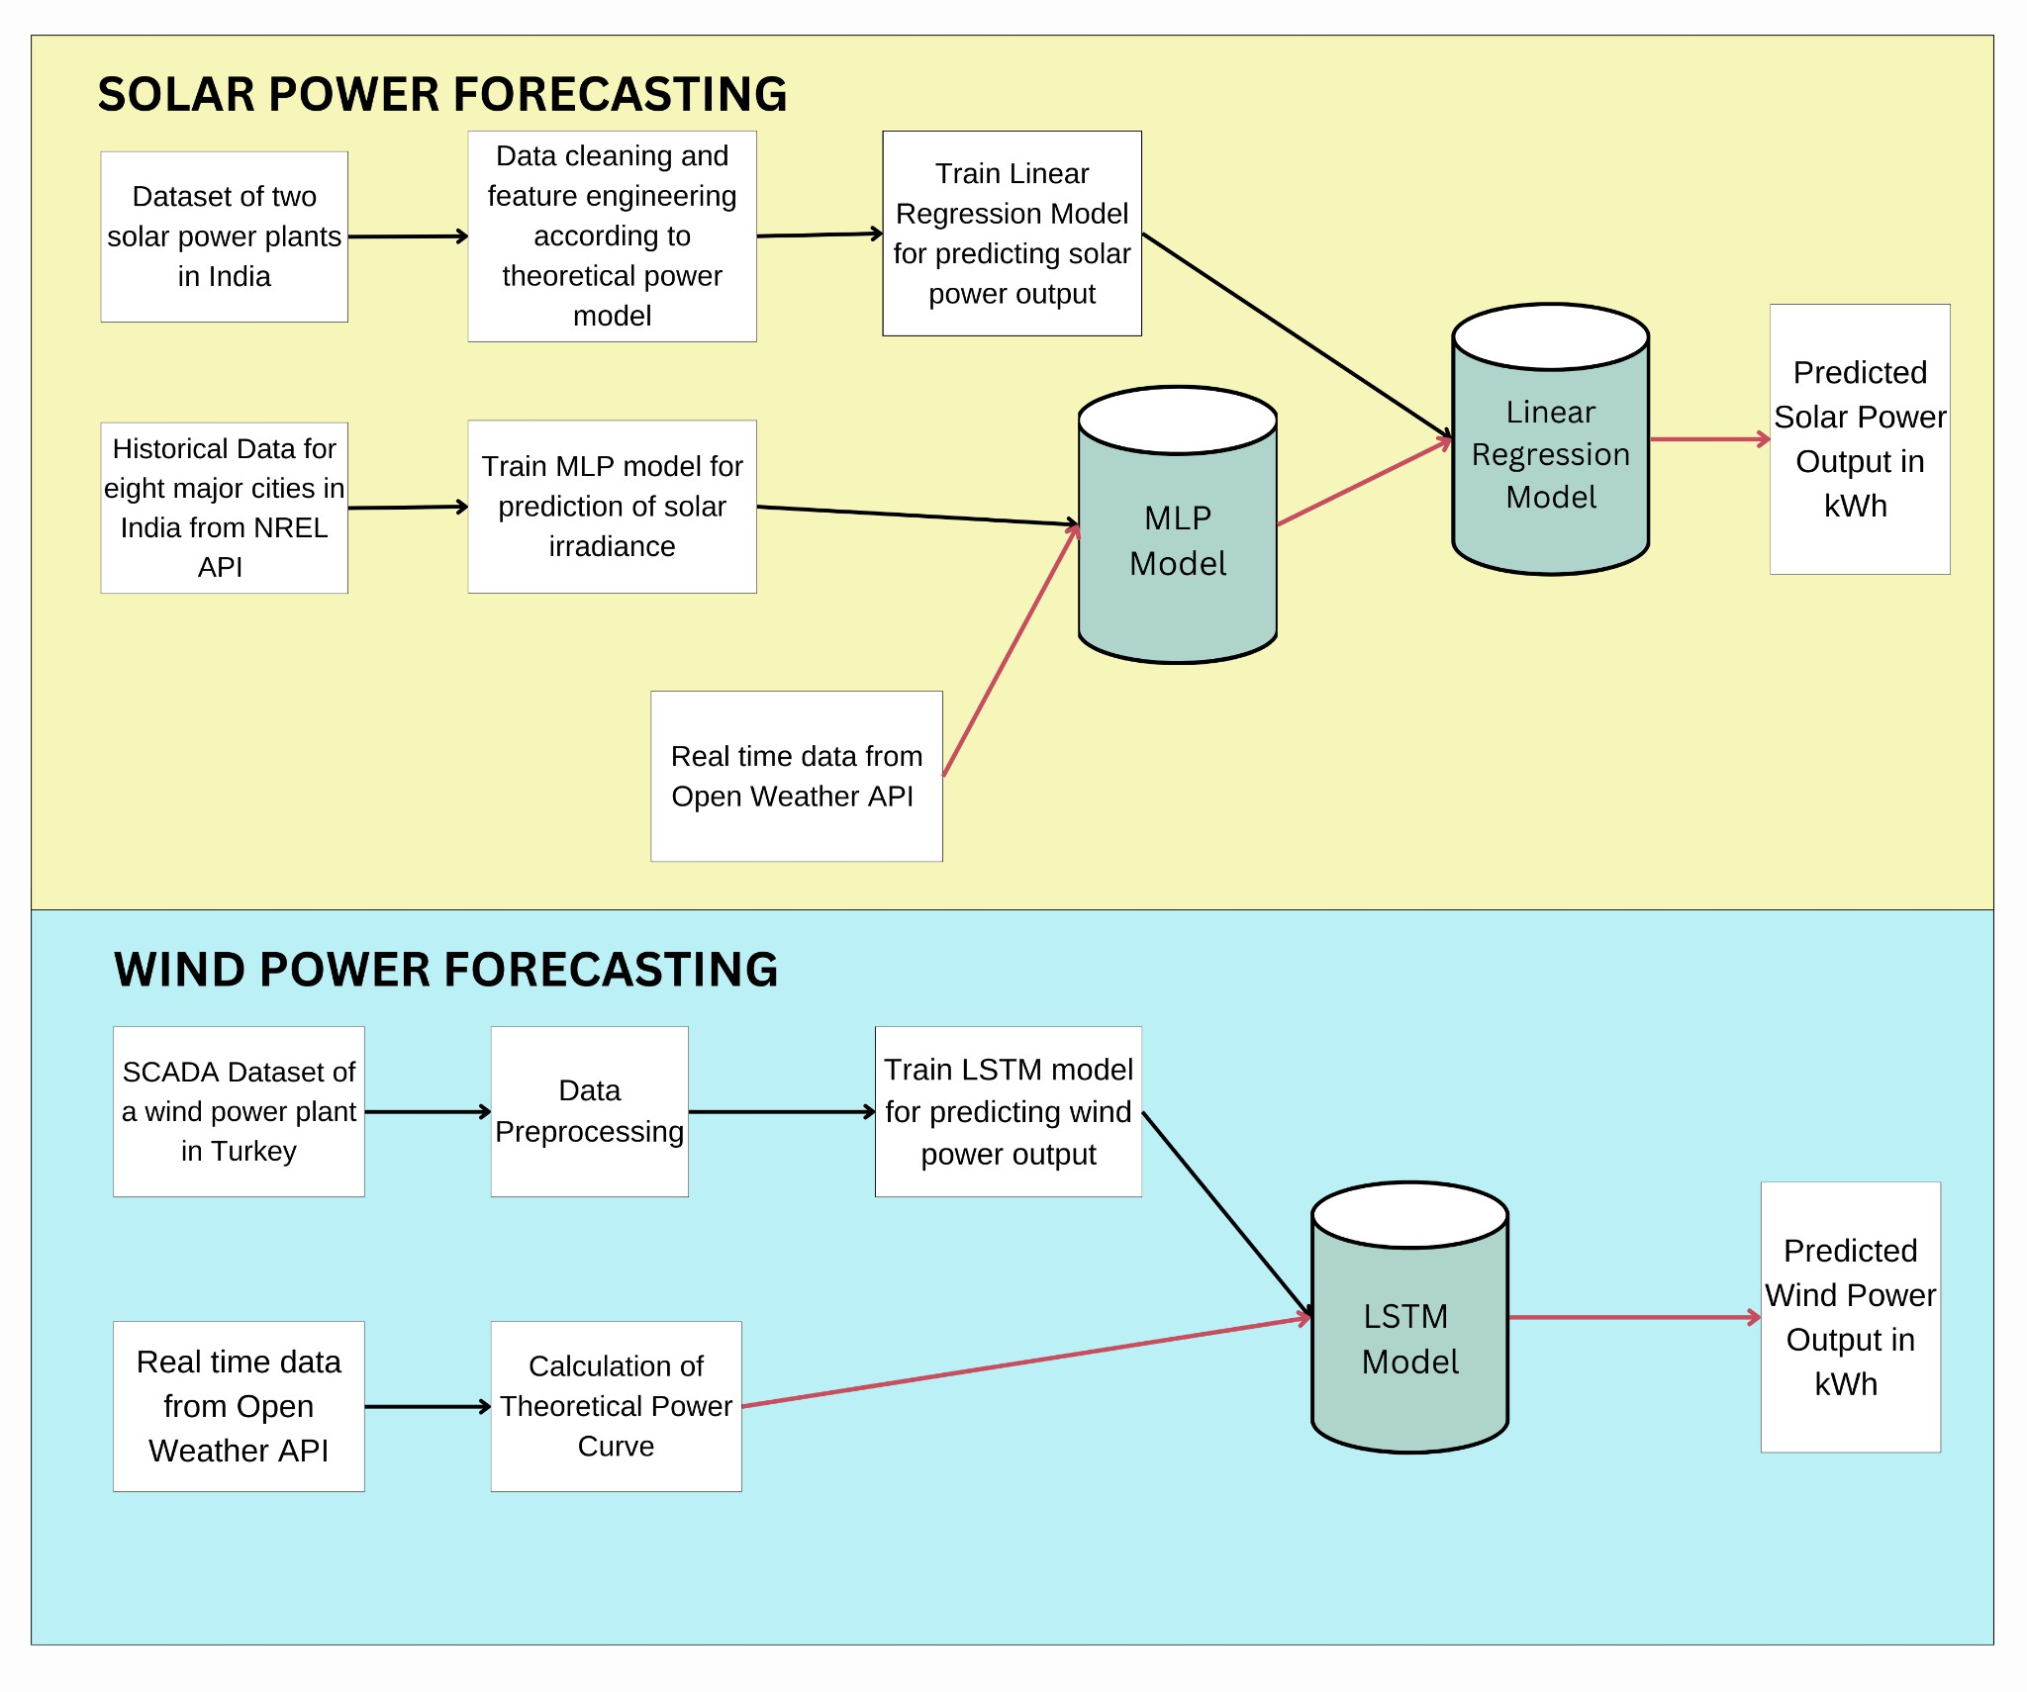The block diagram as seen in Fig. 4.1 offers a detailed breakdown of the system's design, elucidating the working modules. This concise presentation aims to offer a clear understanding of the project's structure.

**Fig 4.1: Block Diagram**

The proposed web-based platform offers energy planners a comprehensive toolset for effective energy planning and resource utilization, focusing on harnessing renewable energy sources optimally. By integrating real-time data and intuitive visualizations, the website enables users to access detailed insights into solar and wind energy generation capacities across major Indian cities like Mumbai, Pune, New Delhi, Kanpur, Nagpur, Hyderabad, Bengaluru, and Jaipur. Through the platform, energy planners can effortlessly compare the current temperature conditions and corresponding energy outputs from solar and wind sources at specific locations. This enables them to make informed decisions regarding energy allocation and planning, ensuring efficient utilization of renewable energy resources. Additionally, the website facilitates dynamic comparisons between solar and wind energy outputs, aiding energy planners in identifying the most suitable renewable energy source for meeting the energy demands of various urban settings.

## Modular design of the system

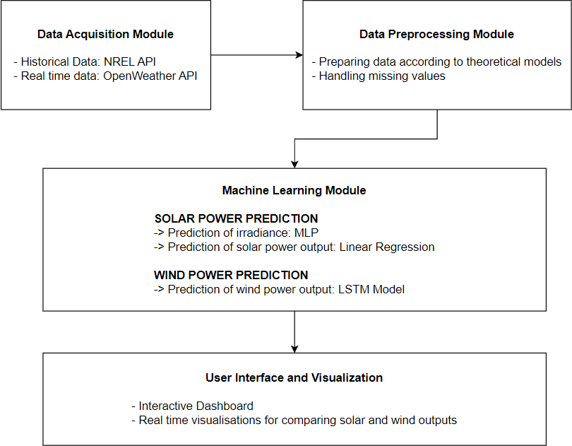

**Fig 4.2: Modular Diagram**

The modular diagram as seen in Fig 4.2 consists of various modules which are explained below. **Data Acquisition:** The system collects real-time environmental data from sources like the OpenWeather API for parameters such as temperature, pressure, humidity, and wind speed. Historical data is obtained from the National Renewable Energy Laboratory (NREL) API.

**Preprocessing:** Data preprocessing involves cleaning, handling missing values, and engineering features to prepare the data for analysis.

**Machine Learning:** The system employs machine learning models for predicting solar and wind power generation. For solar power prediction, regression models and a Multilayer Perceptron (MLP) neural network are utilized. Wind power prediction involves Long Short-Term Memory (LSTM) neural network models for capturing temporal dependencies in wind speed data.

**User Interface:** A web application built using the React.js framework serves as the user interface. It provides visualization tools powered by Matplotlib and an interactive dashboard developed in Jupyter Notebook. Users can access real-time predictions, historical data, and scenario analyses through the intuitive interface.

## Project Scheduling & Tracking using Timeline / Gantt Chart

The gantt chart as seen in Fig. 4.3 visualizes the timeline of the different phases of the project, starting from defining the project scope to the deployment of the project.



**Fig 4.3: Gantt Chart**

# Chapter 5: Implementation of the Proposed System

The implementation chapter describes the methodology employed for developing the system, including algorithms, data sources, and development tools. It discusses the integration of machine learning models for renewable energy prediction and the development of user-friendly interface for the website.

## Methodology employed for development

### Data Cleaning

Addressing missing values in solar power datasets is crucial for ensuring the accuracy and reliability of subsequent analyses. A comprehensive analysis was conducted to identify and handle missing values, revealing distinct patterns during both nighttime and daytime periods. Nighttime gaps, which corresponded to non-operational periods such as routine inspections, were reasonably imputed as zeros to accurately reflect the absence of power generation during these times. However, challenges arose during daylight hours, where intermittent production and unclear reasons suggested potential malfunctions or data recording errors.

To manage missing values during daylight hours, a two-step approach was adopted. First, values were replaced with zeros during specified nighttime hours (18:30 to 6:00) to account for non-operational periods and ensure consistency in data representation. Subsequently, rows with AC power less than or equal to zero during daytime hours (6:30 to 18:00) were selectively removed to address data inconsistencies and maintain the integrity of the dataset.

Similarly, for the wind power dataset, missing values were dropped and the Date/Time feature was converted into a proper format to ensure consistency and ease of handling temporal data for subsequent analysis

### Theoretical Power Model For Solar Power Plants

The theoretical model of a photovoltaic (PV) power plant [17] incorporates equations describing the electrical behavior of PV modules. It typically includes formulations for the Thèvenin voltage and Mayer-Norton current, considering temperature coefficients, standard conditions, and empirical relations for module temperature. The combined model provides a comprehensive understanding of how environmental factors such as solar irradiance and ambient temperature influence the AC power output of a PV system.

The following are the variables considered:

𝑇𝑚: Module temperature represents the temperature of the PV module.

𝑇𝑎:

Ambient temperature signifies the temperature of the surroundings or the external

environment.

𝐺𝑖𝑟: Ground-level sun irradiance or irradiation indicates the solar energy received per unit area.

𝑃𝑎𝑐:

Power Output (AC Power) represents the electrical power output generated by the PV

module.

The following are the constants required:

𝑇𝑜:

Standard Temperature (25°C) represents the standard temperature conditions.𝐺𝑜: Standard

Irradiation (1000 W/m²) signifies the standard solar irradiation conditions.

α: Module Electrical Specification (Temperature Coefficient of Open Circuit Voltage): describes how the open-circuit voltage of the module changes with temperature.

β: Module Electrical Specification (Temperature Coefficient of Short Circuit Current): describes how the short-circuit current of the module changes with temperature.

𝑉𝑜: Open Circuit Voltage at Standard Conditions: represents the voltage across the PV module when no current is flowing.

𝐼𝑜: Short Circuit Current at Standard Conditions: represents the current flowing through the PV module when the voltage across it is zero.

**Theoretical Model:**

The photovoltaic power output (𝑃𝑎𝑐) is modeled as the product of the Thèvenin voltage (𝑉𝑡ℎ) and the Mayer-Norton current (𝐼𝑛𝑜).

𝑃𝑎𝑐 = 𝑉𝑡ℎ · 𝐼𝑛𝑜

Thèvenin voltage and Mayer-Norton current are defined as follows:

𝑉𝑡ℎ = 𝑉𝑜[1 + β(𝑇𝑚 − 𝑇𝑜)]

(1)

(2)

The above equation describes how the Thèvenin voltage changes with temperature, influencing the module's electrical characteristics.

𝐼𝑛𝑜 = 𝐼𝑜[1 + α(𝑇𝑚 − 𝑇𝑜)]( 𝐺𝑖𝑟 )

𝐺𝑜

(3)

The above equation describes how the Mayer-Norton current is influenced by temperature and solar irradiance.

The module temperature is directly proportional to the Irradiation and to the ambient temperature and can be represented by the following empirical formula.

𝑇𝑚 = 30 − 0. 0175(𝐺𝑖𝑟 − 300) + 1. 14(𝑇𝑎 − 25)

On Replacing equations (2), (3), and (4) into equation (1)

(4)

3

𝑃𝑎𝑐 = 𝐾 𝐺𝑖𝑟

2

+ 𝐾 𝐺𝑖𝑟

2 2

+ 𝐾 𝐺𝑖𝑟 𝑇𝑎 + 𝐾 𝐺𝑖𝑟𝑇𝑎

+ 𝐾 𝐺𝑖𝑟𝑇𝑎 + 𝐾 𝐺𝑖𝑟

(5)

1 2 3 4 5 6

Equation (5) derived from the theoretical model provides a foundation for selecting features crucial for predicting AC Power in a photovoltaic (PV) power plant. The identified features offer valuable insights into the interplay between solar irradiance (Gir) and ambient temperature (Ta) on AC Power output. Additionally, the absence of an intercept in the equation signifies that AC Power is predicted to be zero when both solar irradiance and ambient temperature are at their minimum values. To better align the dataset with photovoltaic systems and enhance predictive accuracy, several adjustments were made guided by photovoltaic principles within the theoretical model.

### Feature Engineering

To better align with the theoretical model of a photovoltaic (PV) power plant, we modified the raw data attributes through feature engineering. This process involved creating new features that represent the relationships between solar irradiance (Gir), ambient temperature (Ta), and AC power output more effectively. We standardized solar irradiation by adjusting its scale and introduced new features 𝐺𝑖𝑟3 and interactions such as 2 , to capture complex relationships within the dataset. These enhancements allow our predictive models to better understand the dynamics of solar energy generation, resulting in more accurate forecasts essential for efficient energy planning and management.

𝐺𝑖𝑟 𝑇𝑎

### Machine learning model for predicting solar power output

Several machine learning models were employed to predict solar energy generation, to identify the most suitable regressor for accurately estimating AC power output from photovoltaic systems. These models included Linear Regression, Ridge Regression, Decision Tree Regression, Random Forest Regression, and K Nearest Neighbors Regression. Each model was evaluated based on its ability to capture the relationship between ambient temperature, solar irradiance, and solar energy generation. Through comprehensive analysis, we aimed to determine the most effective model for accurately forecasting solar energy production.

### Deep learning model for predicting irradiation

In the absence of real-time irradiance data, a Multilayer Perceptron (MLP) model was implemented as a robust solution for predicting solar irradiance. This deep learning model architecture is well-suited for capturing complex patterns and relationships within the input data. The MLP consisted of multiple densely connected layers, allowing it to learn intricate dependencies between various environmental factors and irradiance levels. Each layer in the MLP utilized rectified linear unit (ReLU) activation functions, promoting non-linearity and enabling the model to capture nonlinear relationships inherent in solar irradiance prediction. Dropout layers were strategically incorporated to prevent overfitting by randomly deactivating neurons during training, thereby enhancing the model's generalization capability. The model was

trained using historical data obtained from the NREL API for eight cities in India, encompassing a wide range of environmental attributes such as temperature, pressure, relative humidity, wind speed, and wind direction. By optimizing the mean absolute error (MAE) loss function and employing the Adam optimizer with a learning rate of 0.001, the MLP underwent extensive training over 300 epochs with a batch size of 32. This training regimen enabled the model to effectively learn from the input data and accurately predict solar irradiance levels.

### Prediction of solar power output for real-time data

For real-time prediction of solar power output, the proposed system employs a two-step approach using machine learning models. Firstly, real-time environmental data, including temperature, pressure, relative humidity, wind speed, and wind direction, is gathered from the OpenWeather API. This data is then fed into the trained Multilayer Perceptron (MLP) model for the prediction of solar irradiance. The MLP model, previously trained on historical data from the NREL API for accurate irradiance prediction, utilizes its learned patterns and relationships to estimate the current solar irradiance level. Subsequently, the predicted solar irradiance along with the real-time temperature data is combined, feature-engineered according to the theoretical power model, and is fed into a regression model specifically designed for predicting the AC power generated by the solar power plant.

### Deep Learning LSTM model for predicting actual power output for wind power plants

In wind energy forecasting, accurate prediction of power output plays a pivotal role in optimizing energy generation and ensuring grid stability. To address this challenge, the proposed system employs a Long Short-Term Memory (LSTM) neural network model, a variant of recurrent neural networks (RNNs), known for its ability to capture long-term dependencies in sequential data. The LSTM model aims to predict wind turbine power output based on relevant features such as wind speed and theoretical power curve. From the dataset, pertinent features were selected such as wind speed (m/s) and the theoretical power curve (KWh). These features, indicative of wind turbine performance, were normalized using min-max scaling to ensure uniformity across different attributes.

The LSTM model architecture is comprised of a sequential stack of LSTM and Dense layers. The LSTM layer, with 100 units, served as the primary component responsible for learning temporal patterns and dependencies in the input sequences. Subsequently, a Dense output layer was employed to generate predictions based on the learned representations. The model was trained using the Adam optimizer, with mean square error as a loss function over 50 epochs with a batch size of 32.

### Calculation of Theoretical power output for wind power plants

In wind energy prediction, the theoretical power curve plays a pivotal role, serving as a fundamental factor in estimating the energy output of wind turbines. However, obtaining the theoretical power curve directly poses challenges as it is typically dependent on the wind speed at the hub height of the turbine and varies based on turbine specifications determined by the manufacturer. Since this data is not readily available, the proposed system employs a calculation method to estimate the theoretical power output. This approach involves utilizing the formula

P = 0.5 * Cp * ρ * π * R^2 * V^3

where Cp represents the coefficient of performance or efficiency factor (expressed in percent), ρ denotes air density (measured in kg/m^3), R signifies the length of the rotor blades (measured in meters), and V represents the wind speed (measured in meters per second).

Real-time wind speed (V) is extracted from the OpenWeather API, representing a crucial parameter influencing wind turbine performance. The efficiency of a wind turbine, often denoted as Cp, is assumed to be 0.45, a value within the typical range of 0.35 to 0.45 observed for small-scale residential turbines. This assumption reflects the average efficiency expected from modern wind turbine designs. Additionally, the length of the rotor blades (R), set at 5 meters, represents a standard value for small-scale residential turbines commonly deployed in domestic settings. Air density is determined using temperature and humidity data obtained from the API. The formula incorporates dry and vapor air pressure to estimate air density accurately. Finally, the theoretical power output of the wind turbine is calculated by using the formula. This data is then fed to the LSTM model for prediction of wind power generation.

### Website Flow

The website showcases real-time data for eight prominent cities in India, including Mumbai, Pune, New Delhi, Kanpur, Nagpur, Hyderabad, Bengaluru, and Jaipur, offering insights into both solar and wind power generation potential at each location. By providing detailed visualizations and comparisons, the platform equips energy planners with essential information to make informed decisions regarding renewable energy investments. Through real-time updates on solar irradiance levels, ambient temperatures, wind speeds, and theoretical power outputs, the website enables planners to assess the feasibility and economic viability of solar photovoltaic and wind turbine installations in specific regions. This data-driven approach empowers planners to identify optimal locations for renewable energy projects and formulate strategies for sustainable energy development in urban centers across India.

## Algorithms and flowcharts for the respective modules

### Polynomial Regression

Polynomial regression is a type of regression analysis used to model the relationship between independent and dependent variables when the relationship is not linear.

The degree of the polynomial determines the complexity of the model. Higher degrees allow the model to capture more intricate relationships in the data but also increase the risk of overfitting, where the model learns the noise in the training data rather than the underlying pattern.

In the proposed system, regression models are trained using historical data on solar power generation and corresponding environmental factors. Once trained, these models can then be used to predict the amount of solar power that will be generated based on the current or forecasted values of the independent variables

The following is the polynomial regression equation used to calculate the solar power output generated based on the theoretical model.

3

𝑃𝑎𝑐 = 𝐾 𝐺𝑖𝑟

2

+ 𝐾 𝐺𝑖𝑟

2 2

+ 𝐾 𝐺𝑖𝑟 𝑇𝑎 + 𝐾 𝐺𝑖𝑟𝑇𝑎

+ 𝐾 𝐺𝑖𝑟𝑇𝑎 + 𝐾 𝐺𝑖𝑟

1 2 3 4 5 6

### Multi-layer Perceptron

The Multilayer Perceptron (MLP) is a type of artificial neural network (ANN) that consists of multiple layers of nodes, or neurons, arranged in a feedforward manner.

In an MLP, information flows in one direction, from the input layer through one or more hidden layers to the output layer. Each layer is fully connected to the next layer, meaning that every neuron in one layer is connected to every neuron in the next layer.

Each neuron in the MLP performs a weighted sum of its inputs, followed by the application of an activation function. Common activation functions include the sigmoid function, hyperbolic tangent (tanh) function, and rectified linear unit (ReLU) function. These non-linear activation functions introduce non-linearity into the model, allowing it to learn complex relationships in the data. The hidden layers of an MLP allow it to learn hierarchical representations of the input data. By adding more hidden layers and neurons, the model can learn increasingly complex patterns in the data.

The MLP is trained using historical data obtained from sources such as the National Renewable Energy Laboratory (NREL) API. During training, the model learns to associate input features with corresponding output labels (solar irradiance levels) by adjusting the weights and biases of its neurons through a process known as backpropagation. The model is trained to minimize a loss function, such as mean squared error (MSE), which quantifies the difference between the predicted and actual solar irradiance values. The Adam optimizer is commonly used to iteratively update the model's parameters to minimize this loss function. Once trained and validated, the MLP can be used to make predictions on new, unseen data. In the proposed system, the MLP is integrated into the overall prediction pipeline to provide real-time estimates of solar irradiance levels, which are then used in conjunction with the regression model for solar energy generation forecasting

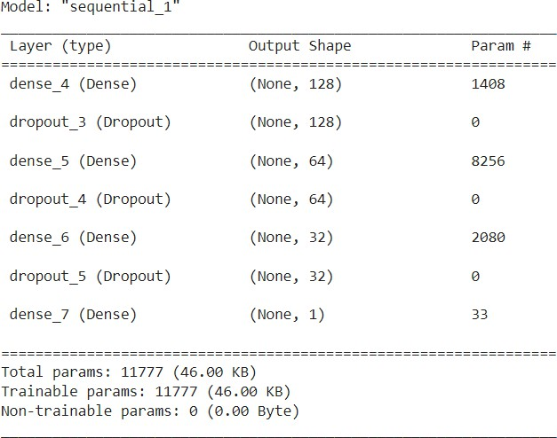

**Fig 5.2.2: Architecture of MLP Model**

### Long Short-Term Memory Model

The Long Short-Term Memory (LSTM) model is a type of recurrent neural network (RNN) architecture designed to address the vanishing gradient problem of traditional RNNs and capture long-range dependencies in sequential data. LSTM models are specifically designed for sequential data, such as time series or natural language text. They process input data one element at a time, maintaining an internal state that captures information from previous elements in the sequence. The key component of an LSTM model is the memory cell, which stores information over time and controls the flow of information through the network. Each memory cell contains three main components: an input gate, a forget gate, and an output gate. The input gate regulates the flow of new information into the memory cell, the forget gate controls the retention or deletion of information from the cell's internal state, and the output gate determines the information that is passed on to the next time step. The LSTM model is trained using historical wind speed data and corresponding power output from wind turbines. During training, the model learns to map sequences of input features (wind speed, etc.) to output predictions (power output). Once trained and validated, the LSTM model can be used to make predictions of wind energy generation based on real-time or forecasted wind speed data.

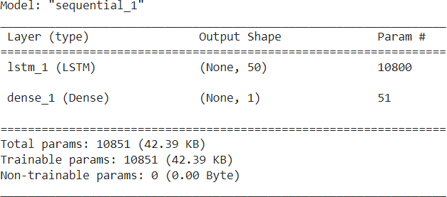

**Fig 5.2.3: Architecture of LSTM Model**

## Datasets source and utilisation

For solar energy prediction, the proposed system has used a Kaggle dataset collected from two solar power plants in India over 34 days. It has two pairs of files - each pair has one power generation dataset and one sensor readings dataset. The power generation datasets are gathered at the inverter level. Each inverter has multiple lines of solar panels attached to it. The sensor data is gathered at the plant level by a single array of sensors optimally placed at the plant. The attributes considered for the prediction of AC power generation are the date and time for each observation recorded at 15-minute intervals, plant ID and source key for each inverter, DC power generated by the inverter, AC power generated by the inverter, daily yield which is the cumulative sum of power generated on that particular day up to the current time and total yield which is the total accumulated yield of the inverter up to that point in time. Various weather sensor readings were also considered like the ambient temperature at the plant location, the temperature reading for the solar panel module attached to the sensor panel, and the amount of irradiation during the 15-minute interval. This data was used to train the machine learning algorithm for predicting the amount of solar energy generated. Moreover, historical data for eight cities namely Mumbai, Bengaluru, Hyderabad, Kanpur, Jaipur, New Delhi, Nagpur, and Pune was extracted from the NREL API and was employed to train a deep learning model for predicting solar irradiance (GHI) values based on attributes such as temperature, wind speed, wind direction, relative humidity and the date-time stamp. For wind energy prediction, the

dataset utilized is obtained from a SCADA system installed on a wind turbine situated in Turkey, offering crucial insights into its operational dynamics. Recorded at 10-minute intervals, the dataset encompasses essential attributes, including date/time stamps, LV ActivePower (kW) indicating the actual power generated, wind speed (m/s) representing the turbine's operational environment, Theoretical power curve (KWh) reflecting manufacturer-provided theoretical power values corresponding to observed wind speeds, and Wind Direction (°) denoting the prevailing wind orientation at the turbine's hub height. Finally, real-time data is fetched from the Open Weather API, this data consists of weather conditions including temperature, wind speed, wind direction, relative humidity, and atmospheric pressure, which are instrumental in predicting the potential solar and wind energy generation, particularly applicable to residential settings or small-scale installations utilizing compact solar panels and wind turbines with rotor blades of 5 meters in length.

# Chapter 6: Testing of the Proposed System

This chapter focuses on testing the functionality, reliability, and usability of the developed system. It aims to validate the system's performance and identify any issues for improvement, ensuring its effectiveness in addressing stakeholders' needs and establishing its credibility and reliability.

## Introduction to testing :

Testing is an essential phase in the software development lifecycle (SDLC) that ensures the reliability, functionality, and quality of the developed software. It involves systematically executing the software components or system to identify any defects or errors that may affect its performance or user experience.

The primary objective of testing is to validate whether the software meets the specified requirements and behaves as expected under different conditions. In the context of our project, testing plays a crucial role in verifying the correctness and robustness of the software solution we have developed. By subjecting the software to various test scenarios, we aim to uncover any discrepancies between the actual and expected behaviour, enabling us to rectify issues and enhance the overall quality of the product.

The testing process encompasses several phases, starting from the early stages of development and continuing throughout the project lifecycle. Furthermore, testing is not limited to functional aspects alone but also encompasses non-functional aspects such as performance, security, usability, and compatibility. These aspects are equally important in delivering a successful software solution that meets the needs and expectations of end-users.

In our project, we have adopted a comprehensive testing approach that combines both manual and automated testing techniques. Manual testing allows for human judgment and exploration of the software's behavior, while automated testing aids in repetitive and regression testing tasks, ensuring efficiency and consistency.

## Types of tests considered :

In our project, we have adopted a comprehensive testing strategy that encompasses various types of tests to ensure thorough validation of the software solution. Two fundamental approaches that we have employed are black box testing and white box testing.

Black Box Testing:

Black box testing, also known as functional testing, focuses on evaluating the software's functionality without considering its internal structure or implementation details. Test cases are designed based on the system's specifications and requirements, treating the software as a black box. During black box testing, testers interact with the software through its interfaces, inputs, and outputs to validate whether it behaves as expected under different conditions. This approach helps identify issues related to incorrect or missing functionality, user interface flaws, and integration problems, ensuring that the software meets the end-users' requirements and expectations.

White Box Testing:

White box testing, in contrast to black box testing, examines the internal structure and logic of the software system. Also referred to as structural testing or glass box testing, this approach involves analyzing the source code, design documents, and architecture to devise test cases that exercise specific paths, conditions, and branches within the code. White box testing aims to uncover defects related to logic errors, coding mistakes, and performance bottlenecks that may not be apparent through black box testing alone. By gaining insight into the internal workings of the software, white box testing enables us to verify the correctness of individual components, ensure code coverage, and optimize the software's efficiency and maintainability.

By incorporating both black box and white box testing techniques into our testing strategy, we aim to achieve comprehensive test coverage and maximize the detection of defects across different layers of the software. This hybrid approach allows us to address functional and structural aspects effectively, resulting in a more robust and reliable software solution.

## Various test case scenarios considered :

**Black box testing**

* + 1. **User Interface Testing:**

Ensure all user interface elements are functional, including buttons, input fields, dropdown menus, and navigation links.

Verify that the user interface is responsive and displays correctly on different devices and screen sizes.

Validate the consistency of design elements, typography, colors, and layout across all pages of the application.

* + 1. **Real-Time Data Accuracy Testing:**

Collect real-time data from external sources or APIs and compare it with the data displayed in the system.

Verify that the real-time data updates correctly and reflects the latest information available from the source.

Test the system's ability to handle fluctuations in real-time data and ensure that it updates consistently and accurately.

Validate the timestamps associated with real-time data to ensure they match the current time and date.

* + 1. **Forecast Testing:**

Input historical data into the system and generate forecasts for future time periods. Compare the forecasted values with actual values observed after the forecast period to assess accuracy.

Test the system's forecasting algorithms under various scenarios and conditions to evaluate performance.

Verify that the system provides reliable and timely forecasts that align with expected trends and patterns.

* + 1. **Visualization Testing:**

Verify that data visualizations, such as charts, graphs, and maps, are generated correctly and accurately represent the underlying data.

Test the interactivity of visualizations, such as zooming, panning, and filtering, to ensure they respond smoothly to user interactions.

Validate the accessibility of visualizations for users with disabilities, such as providing alternative text for images and supporting screen reader navigation.

Ensure that visualizations are displayed consistently across different browsers and devices and that they maintain clarity and legibility at various screen resolutions.

**White Box Testing:**

1. **Unit Testing:**

Writing unit tests for individual functions or modules responsible for handling solar and wind energy prediction. Testing different scenarios such as valid input, invalid input, and edge cases to ensure robustness.

1. **Integration Testing:** Testing the integration between frontend and backend components. Verifying that data is passed correctly between different layers of the application.
2. **Performance Testing:** Measuring the performance of the application when handling real-time data uploads and processing for solar and wind energy forecasting.

## Inference drawn from the test cases :

**User Interface Testing:**

The user interface is intuitive, easy to navigate, and responsive across different devices and screen sizes. The proposed system provides a user-friendly interface that enhances user experience and usability.

**Real-time Data Accuracy Testing:**

Real-time data displayed on the system matches the actual data obtained from external sources with minimal latency. The system effectively retrieves, processes, and presents real-time data, ensuring accuracy and timeliness for decision-making.

**Forecast Testing:**

Forecasted energy generation trends closely align with historical data and exhibit reasonable predictions for future periods. The forecasting algorithms employed in the system demonstrate reliability and effectiveness in predicting energy generation patterns.

**Visualization Testing:**

Data visualizations, such as charts, graphs, and maps, are visually appealing, informative, and convey insights effectively. The visualization components enhance data understanding and facilitate data-driven decision-making for energy planning and management.

**Unit Testing:**

Individual components and functions of the system behave as expected and produce correct outputs for various input conditions. The core functionalities of the system are implemented correctly and exhibit the desired behavior in isolation.

**Integration Testing:**

Different modules and components of the system integrate seamlessly and exchange data accurately without compatibility issues. The system architecture is well-designed, and the integration points function correctly, ensuring proper communication between system elements.

**Performance Testing:**

The system maintains acceptable performance levels under different load conditions, with response times and throughput meeting performance criteria. The system is capable of handling expected user loads and provides satisfactory performance in terms of speed and scalability.

# Chapter 7: Results and Discussion

The results and discussion chapter presents the outcomes of the implemented system, including performance metrics and comparison with existing solutions. It provides an analysis of the system's efficacy and discusses potential areas for further enhancement.

## Screenshots of User Interface (UI):



**Fig 7.1.1: Website UI : City Dashboard**

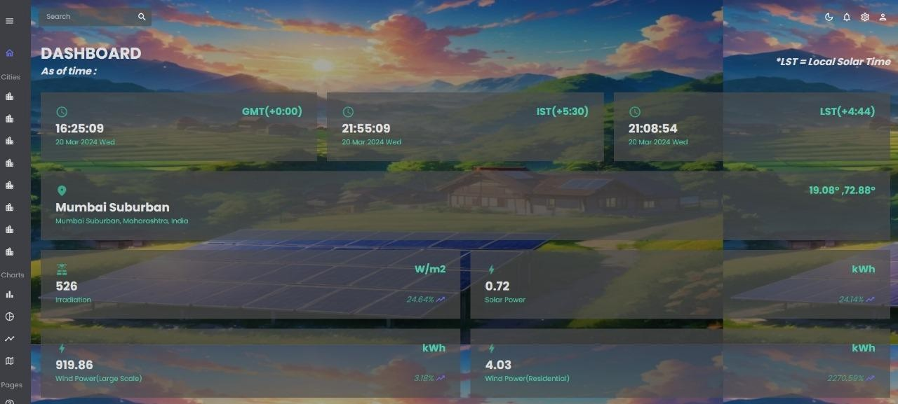

**Fig 7.1.2: Website UI: Mumbai Dashboard**

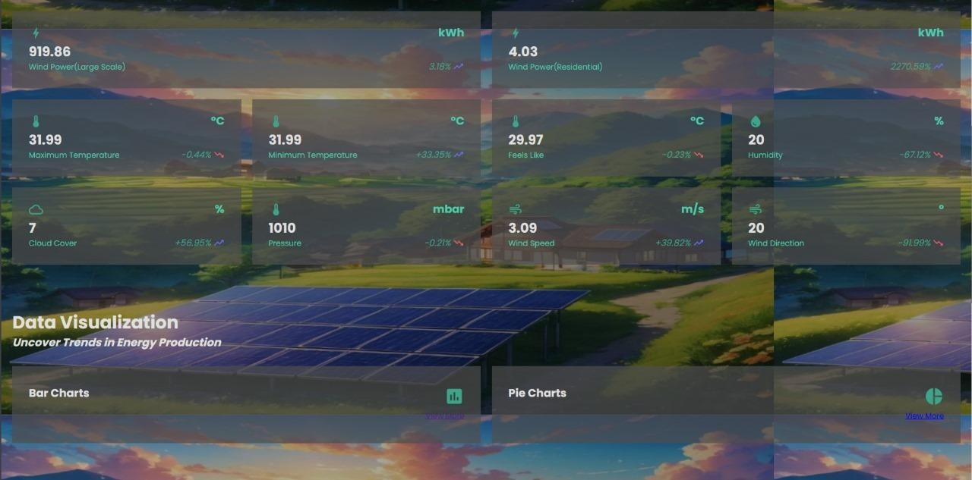

**Fig 7.1.3: Website UI: Mumbai Dashboard**

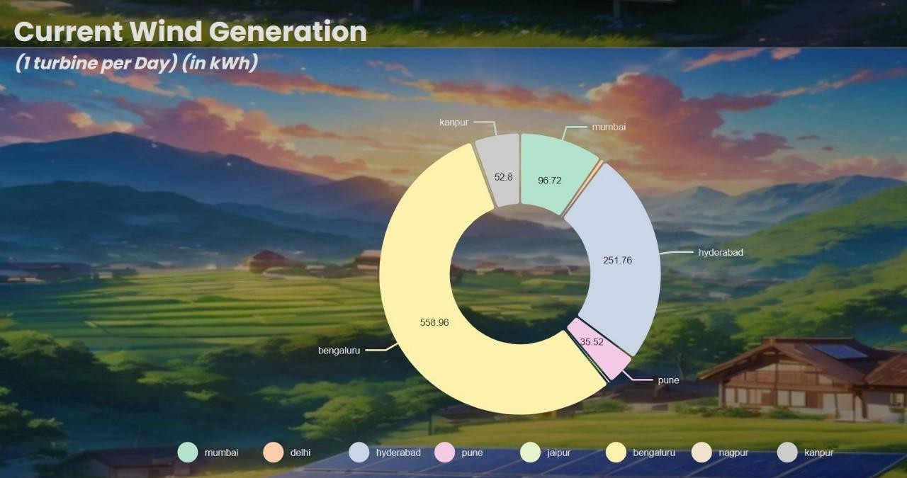

**Fig 7.1.4: City-wise real-time wind energy output visualization**

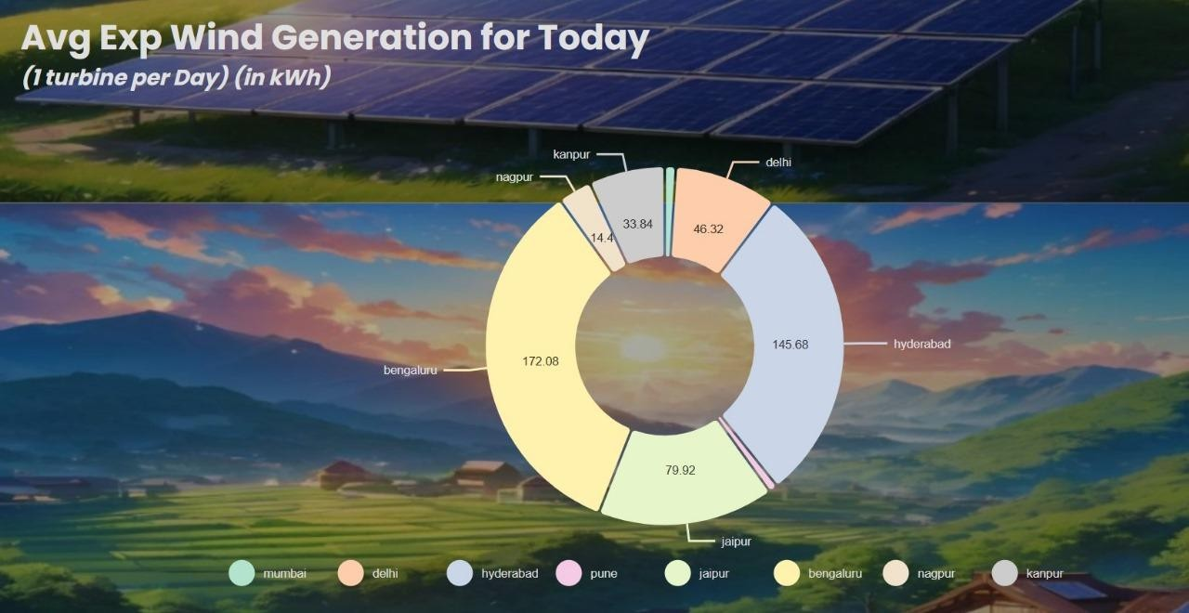

**Fig 7.1.5: City-wise daily average wind energy output visualization**

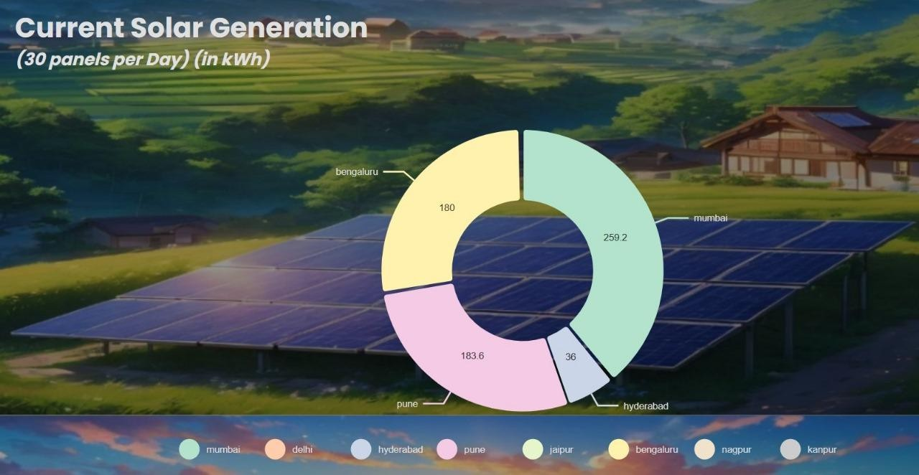

**Fig 7.1.6: City-wise real-time solar energy output visualization**

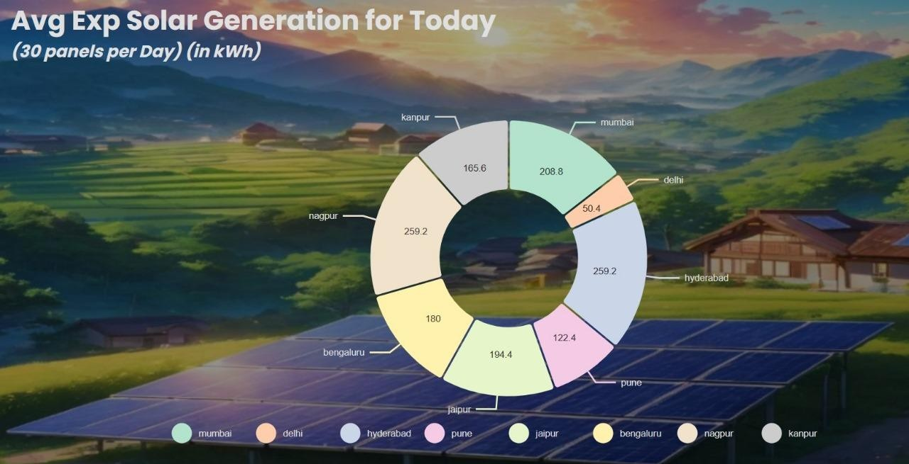

**Fig 7.1.7: City-wise daily average solar energy output visualization**

## Performance Evaluation measures

* + 1. **Mean Squared Error (MSE)**

MSE measures the average squared difference between the actual and predicted values. It penalizes large errors more than smaller ones.

Lower MSE indicates better model performance, with zero representing a perfect fit.

MSE = Σ(*yi* − *pi*)2/ *n*

* + 1. **Mean Absolute Error (MAE):**

MAE measures the average absolute difference between the actual and predicted values. It provides a more intuitive understanding of error magnitude compared to MSE.

Lower MAE indicates better model performance.

𝑛

MAE = 1 ∑ |𝑦 − 𝑦 |

𝑛 | 𝑖

𝑖=1

𝑖|

* + 1. **R-squared (R2):**

R2 represents the proportion of variance in the dependent variable (target) that is explained by the independent variables (features) in the model.

It ranges from 0 to 1, where 1 indicates a perfect fit.

Higher R2 values indicate better model performance in explaining the variance.

2

𝑅 = 1 −

𝑆𝑆

𝑟𝑒𝑠

𝑆𝑆

𝑡𝑜𝑡

## Input Parameters / Features considered

**Solar Power Generation:**

* Solar Irradiance: Amount of solar energy received per unit area.
* Ambient Temperature: Temperature of the surrounding environment.
* Module Temperature: Temperature of the solar panels.
* Time of Day: Solar power generation varies throughout the day.
* Date: Solar power generation may vary based on seasonal changes.

**Wind Power Generation:**

* Wind Speed: Speed of the wind, which directly affects turbine performance.
* Wind Direction: Direction from which the wind is blowing.
* Air Density: Density of the air, which impacts turbine efficiency.
* Temperature: Ambient temperature affecting air density and turbine performance.
* Pressure: Atmospheric pressure influencing wind patterns.

## Graphical and statistical output

**Solar Power Energy Prediction**

The study investigated the performance of various regression models in predicting solar energy output based on historical data from two photovoltaic power plants in India. Linear Regression, Ridge Regression, Decision Tree Regression, Random Forest Regression, and K Nearest Neighbors Regression were evaluated using factors like solar irradiance, ambient temperature, and AC power output.

Linear Regression emerged as the most accurate model and obtained a negative MSE of

-3296.167 as seen in Table 1, showcasing its reliability despite its simplicity. Its straightforward linear relationship effectively captured underlying patterns, outperforming more complex models.

**Table 1. Results of Regression Models**

|  |  |
| --- | --- |
| **Regressor** | **Negative MSE** |
| Linear | -3296.167 |
| Ridge | -3329.264 |
| Decision Tree | -4067.456 |
| Random Forest | -6769.462 |
| KNN | -9986.437 |

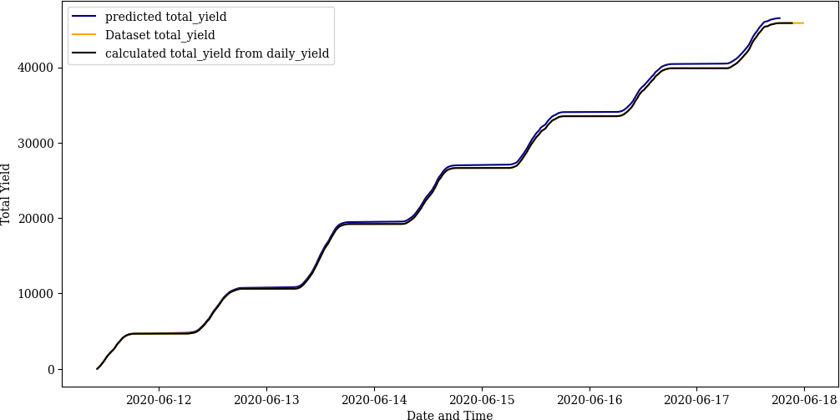

**Fig 7.4.1: Actual vs predicted values of solar power generated over time**

Further, for the prediction of solar irradiation values for real-time data, a multilayer perceptron model was trained using weather data sourced from the National Renewable Energy Laboratory (NREL) API across eight Indian cities. Leveraging features such as temperature, pressure, relative humidity, and wind speed, the MLP model demonstrated adeptness in forecasting solar irradiance accurately and obtained a Mean Absolute Error (MAE) of 43.0289. Table 2 compares the actual and predicted irradiation values for Mumbai.

**Table 2. Actual and predicted values of irradiation for Mumbai**

|  |  |
| --- | --- |
| **Actual Irradiance Value** | **Predicted Irradiance Value** |
| 1.24 | 1.238230 |
| 1.22 | 1.228392 |
| 206.02 | 259.913300 |
| 1.23 | 1.237026 |
| 576.27 | 587.382141 |

**Wind Power Energy Prediction**

For wind power prediction, the system utilized a Long Short Term Memory (LSTM) model. The model was trained on historical wind speed data retrieved from wind turbines' SCADA system. This model demonstrated proficiency in capturing intricate temporal relationships, thereby enabling accurate forecasts of wind energy generation. The model obtained a Mean Absolute Percent Error of 0.4615. Table 3 illustrates the comparison between actual and predicted wind power values for the test dataset.

**Table 3. Actual and predicted values of wind power generation**

|  |  |  |
| --- | --- | --- |
| **Hour** | **Actual** | **Predicted** |
| 1 | 3600.000 | 3606.497 |
| 5 | 1954.283 | 2513.598 |
| 10 | 3257.240 | 3151.348 |
| 15 | 1861.757 | 2292.190 |
| 20 | 3469.777 | 3594.405 |

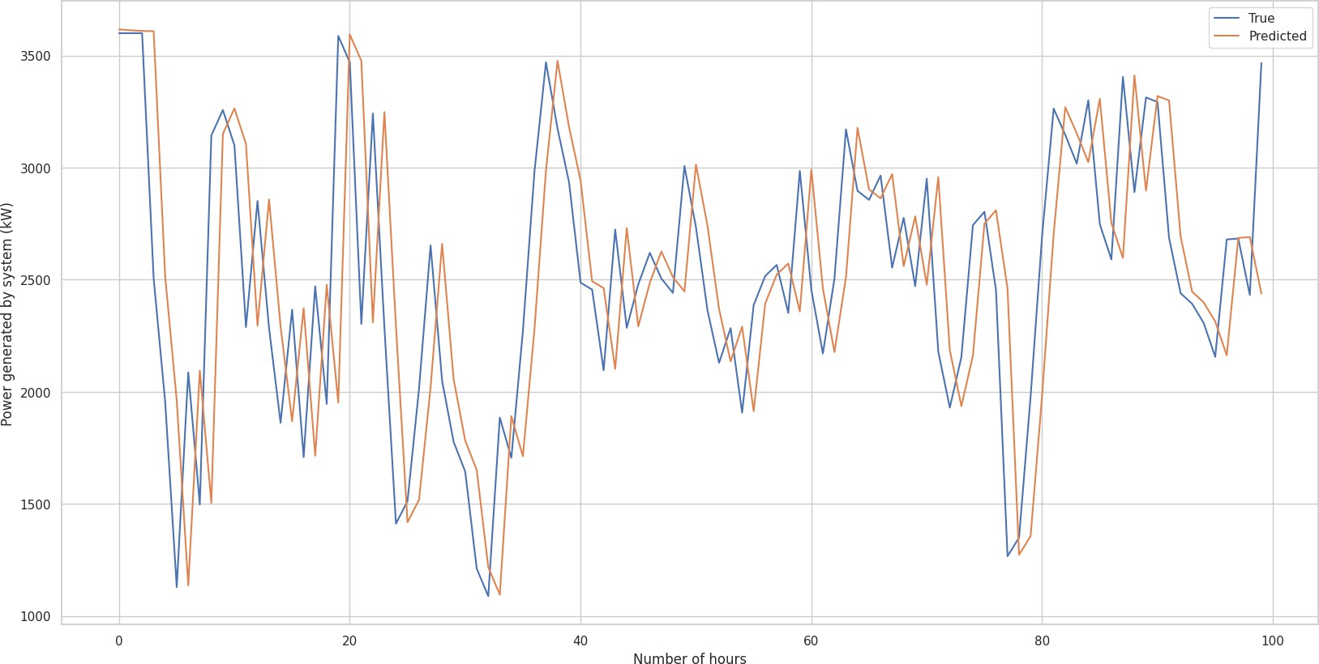

**Fig 7.4.2: Actual vs predicted values of wind power generated over time**

**Comparison of Predicted Solar and Wind Energy Generation**

Table 4 presents data on solar and wind energy generation in Mumbai from March 14th, 2024, to March 18th, 2024. The weather data is gathered from the OpenWeather API and the theoretical power and irradiance values are calculated as specified in the methodology of the system. This data is fed to the machine learning models to predict the amount of solar and wind energy that can be generated at various times during the day providing insights into the potential of these renewable energy sources for residential regions. From the data, it's observed that solar energy production fluctuates throughout the day, peaking during midday when solar irradiance is highest. Notably, wind power generation tends to be higher compared to solar energy. This observation can be attributed to Mumbai's coastal location, which experiences frequent winds due to its proximity to the sea. The coastal environment creates favorable conditions for wind energy production, contributing to its prominence in the energy mix.

**Table 4. Predicted solar and wind energy output for Mumbai**

|  |  |  |  |  |  |  |  |  |  |  |
| --- | --- | --- | --- | --- | --- | --- | --- | --- | --- | --- |
| **Date** | **Time** | **Theoretical Power** | **Tempe rature** | **Relative Humidity** | **Pressure** | **Wind Speed** | **Wind**  **Direction** | **GHI** | **Solar Energy** | **Wind Energy** |
| 14-03-24 | 10:00:00 | 0.63 | 37.36 | 41.64 | 1013 | 3.13 | 266.45 | 852 | 1.08 | 4.54 |
| 14-03-24 | 13:00:00 | 2.52 | 33.36 | 41.27 | 1010.91 | 4.97 | 301 | 884 | 1.13 | 22.64 |
| 14-03-24 | 18:00:00 | 0.78 | 29.91 | 53.73 | 1011.64 | 3.36 | 324 | 592 | 0.81 | 7.07 |
| 14-03-24 | 21:00:00 | 0.30 | 29.09 | 55.27 | 1012.64 | 2.45 | 197.45 | 33 | 0.03 | 0.66 |
| 15-03-24 | 10:00:00 | 0.53 | 36.8 | 42.18 | 1012.73 | 2.95 | 249 | 817 | 1.04 | 3.02 |
| 15-03-24 | 13:00:00 | 1.96 | 33.64 | 42.36 | 1010.55 | 4.57 | 287 | 851 | 1.09 | 20.6 |
| 15-03-24 | 18:00:00 | 0.52 | 30.82 | 55 | 1011.36 | 2.93 | 283.8 | 581 | 0.79 | 2.86 |
| 15-03-24 | 21:00:00 | 0.14 | 30.18 | 56.64 | 1012.55 | 1.89 | 266.8 | 26 | 0.02 | 0.11 |
| 16-03-24 | 10:00:00 | 0.47 | 37.73 | 41.27 | 1012.18 | 2.83 | 251 | 829 | 1.05 | 2.23 |
| 16-03-24 | 13:00:00 | 1.89 | 34.73 | 41.36 | 1010 | 4.52 | 289 | 875 | 1.11 | 20.25 |
| 16-03-24 | 18:00:00 | 51.49 | 31.82 | 54.82 | 1011.09 | 2.93 | 309.73 | 603 | 0.81 | 2.84 |

|  |  |  |  |  |  |  |  |  |  |  |
| --- | --- | --- | --- | --- | --- | --- | --- | --- | --- | --- |
| 16-03-24 | 21:00:00 | 0.08 | 30.73 | 57.82 | 1012.27 | 1.57 | 198.73 | 20 | 0.01 | 0.06 |
| 17-03-24 | 10:00:00 | 0.45 | 38 | 42.36 | 1013.45 | 2.8 | 276 | 828 | 1.05 | 2.07 |
| 17-03-24 | 13:00:00 | 2.20 | 34.36 | 42.82 | 1010.27 | 4.75 | 290.09 | 873 | 1.11 | 21.63 |
| 17-03-24 | 18:00:00 | 0.57 | 31.45 | 56.36 | 1011.09 | 3.03 | 314.45 | 594 | 0.8 | 3.6 |
| 17-03-24 | 21:00:00 | 0.18 | 30.82 | 60.27 | 1012.27 | 2.05 | 270 | 35 | 0.03 | 0.13 |
| 18-03-24 | 10:00:00 | 0.54 | 38.36 | 42.73 | 1012.45 | 2.98 | 275 | 852 | 1.07 | 3.24 |
| 18-03-24 | 13:00:00 | 2.52 | 34.27 | 42.36 | 1010.18 | 4.97 | 282.9 | 894 | 1.13 | 22.63 |
| 18-03-24 | 18:00:00 | 0.72 | 31.64 | 54.82 | 1010.9 | 3.28 | 310.2 | 621 | 0.84 | 6.08 |
| 18-03-24 | 21:00:00 | 0.17 | 30.82 | 60.27 | 1012.09 | 2.02 | 253.09 | 34 | 0.03 | 0.13 |

## Comparison of results with existing systems

The proposed system represents a significant advancement in renewable energy forecasting and management, offering real-time insights and precise predictions. In comparison to existing systems, our solution provides superior performance and functionality, as outlined in table 5 below.

**Table 5. Comparison of results with existing systems**

|  |  |
| --- | --- |
| **Proposed System** | **Existing Systems** |
| Integrates real-time data from multiple sources | Relies on static or outdated data |
| Offers dynamic comparisons between solar & wind | Limited to either solar or wind forecasting alone |
| Enables scenario analyses and accurate forecasting | Lacks advanced predictive modeling capabilities |
| Provides insights into solar and wind generation | Focuses solely on power generation without insights |
| Empowers energy planners with data-driven decisions | Relies on manual or less data-driven planning |
| Offers a user-friendly interface for easy navigation | Interfaces may be complex or lack user-friendliness |

## Inference drawn

* + 1. Real-time Data Integration: Our system integrates real-time data from multiple sources, enabling more accurate and up-to-date forecasting compared to systems relying on static or outdated data.
    2. Comprehensive Insights: Unlike existing systems that may focus solely on power generation without insights, our system provides comprehensive insights into both solar and wind generation capacities, empowering energy planners with a deeper understanding of energy dynamics.
    3. Advanced Predictive Modeling: Our system employs advanced predictive modeling techniques, such as machine learning and deep learning, allowing for more accurate forecasting and scenario analyses compared to systems lacking such capabilities.
    4. User-Friendly Interface: With a user-friendly interface, our system ensures easy navigation and accessibility for energy planners, enhancing their ability to make informed decisions and optimize resource allocation effectively.

# Chapter 8: Conclusion

The conclusion chapter summarises the project's objectives, achievements, and implications for the agricultural sector. It emphasises the importance of technological innovations in improving adoption of sustainable energy practices and suggests avenues for future research and development, highlighting the project's contributions and paving the way for continued advancements in predictive analytics of renewable energy.

## Limitations

* + 1. Dependency on Data Quality: The accuracy and reliability of our system heavily rely on the quality of the input data, including real-time sensor readings and historical datasets. Poor data quality or inconsistencies could affect the performance of the forecasting models.
    2. Sensitivity to Environmental Factors: Our system's predictive accuracy may be impacted by sudden environmental changes or extreme weather events that are challenging to forecast accurately. Variations in solar irradiance, wind speed, or ambient temperature could lead to deviations from predicted energy generation.
    3. Regional Limitations: Our system's applicability may be limited to regions where reliable real-time data is available and where solar and wind energy generation is viable. It may not be suitable for areas with limited renewable energy potential or inadequate infrastructure for data collection.
    4. Regulatory and Policy Constraints: Regulatory policies and market dynamics in the renewable energy sector could impact the adoption and implementation of our system. Compliance with regulations and navigating policy frameworks may pose challenges for deployment in some regions.

## Conclusion

Renewable energy plays a crucial role in meeting contemporary energy demands while addressing environmental concerns. The proposed system employs predictive modelling techniques to forecast both solar and wind energy generation. By integrating these models into an intuitive web platform, the system enables real-time monitoring of energy production potential across major Indian cities. Through comprehensive visualizations and comparative analyses, energy planners gain valuable insights to optimize renewable energy utilization for smart cities and residential areas. The website can predict the generation of real-time data, providing up-to-the-minute information on energy availability and facilitating proactive energy management strategies. The linear regression model for solar energy prediction obtained a negative MSE of -3296.167, and the LSTM model for wind energy prediction obtained a MAPE of 0.4615. This holistic approach fosters sustainable energy practices and contributes to building greener, more resilient urban communities in India.

## Future Scope

* Integration of more advanced machine learning models for improved accuracy and robustness in energy generation prediction.
* Expansion of geographical coverage to include additional regions and cities, enabling broader adoption and applicability of the system.
* Incorporation of real-time satellite imagery and weather forecasting data to enhance the precision of solar irradiance and wind speed predictions.
* Development of mobile applications for remote monitoring and management of renewable energy systems, catering to the needs of on-the-go users.
* Exploration of hybrid renewable energy systems, combining solar, wind, and other sources, to optimize energy generation and storage capabilities

# References

1. A. Nayak and L. Heistrene, "Hybrid Machine Learning Model for Forecasting Solar Power Generation," 2020 International Conference on Smart Grids and Energy Systems (SGES), Perth, Australia, 2020, pp. 910-915, doi: 10.1109/SGES51519.2020.00167.
2. Bouchaib Zazoum,Solar photovoltaic power prediction using different machine learning methods, Energy Reports, Volume 8, Supplement 1, 2022, Pages 19-25,ISSN 2352-4847, <https://doi.org/10.1016/j.egyr.2021.11.183>.
3. M. Z. Hassan, M. E. K. Ali, A. B. M. S. Ali and J. Kumar, "Forecasting Day-Ahead Solar Radiation Using Machine Learning Approach," 2017 4th Asia-Pacific World Congress on Computer Science and Engineering (APWC on CSE), Mana Island, Fiji, 2017, pp. 252-258, doi: 10.1109/APWConCSE.2017.00050.
4. S. Mishra, L. Tripathy, P. Satapathy, P. K. Dash and N. Sahani, "An Efficient Machine Learning Approach for Accurate Short Term Solar Power Prediction," 2020 International Conference on Computational Intelligence for Smart Power System and Sustainable Energy (CISPSSE), Keonjhar, India, 2020, pp. 1-6, doi: 10.1109/CISPSSE49931.2020.9212231.
5. A. M. Alam, Nahid-Al-Masood, I. Asif Razee and M. Zunaed, "Solar PV Power Forecasting Using Traditional Methods and Machine Learning Techniques," 2021 IEEE Kansas Power and Energy Conference (KPEC), Manhattan, KS, USA, 2021, pp. 1-5, doi: 10.1109/KPEC51835.2021.9446199.
6. W. Buwei, C. Jianfeng, W. Bo and F. Shuanglei, "A Solar Power Prediction Using Support Vector Machines Based on Multi-source Data Fusion," 2018 International Conference on Power System Technology (POWERCON), Guangzhou, China, 2018, pp. 4573-4577, doi: 10.1109/POWERCON.2018.8601672
7. T. Hai et al., "Global Solar Radiation Estimation and Climatic Variability Analysis Using Extreme Learning Machine Based Predictive Model," in IEEE Access, vol. 8, pp. 12026-12042, 2020, doi: 10.1109/ACCESS.2020.2965303.
8. Li, Z., Ye, L., Zhao, Y. et al. Short-term wind power prediction based on extreme learning machine with error correction. Prot Control Mod Power Syst 1, 1 (2016). <https://doi.org/10.1186/s41601-016-0016-y>
9. Y. Zhang, H. Sun and Y. Guo, "Wind Power Prediction Based on PSO-SVR and Grey Combination Model," in IEEE Access, vol. 7, pp. 136254-136267, 2019, doi: 10.1109/ACCESS.2019.2942012.
10. A. Kerem, A. Saygin and R. Rahmani, "Wind Power Forecasting Using a New and Robust Hybrid Metaheuristic Approach: A Case Study of Multiple Locations," 2019 19th International Symposium on Electromagnetic Fields in Mechatronics, Electrical and Electronic Engineering (ISEF), Nancy, France, 2019, pp. 1-2, doi: 10.1109/ISEF45929.2019.9097023.
11. A. Kumar and A. B. M. S. Ali, "Prospects of wind energy production in the western Fiji — An empirical study using machine learning forecasting algorithms," 2017 Australasian Universities Power Engineering Conference (AUPEC), Melbourne, VIC, Australia, 2017, pp. 1-5, doi: 10.1109/AUPEC.2017.8282443.
12. M. A. Ehsan, A. Shahirinia, N. Zhang and T. Oladunni, "Wind Speed Prediction and Visualization Using Long Short-Term Memory Networks (LSTM)," 2020 10th International Conference on Information Science and Technology (ICIST), Bath, London, and Plymouth, UK, 2020, pp. 234-240, doi: 10.1109/ICIST49303.2020.9202300.
13. S. Adjiri, H. Nedjari-Daaou and S. M. Boudia, "Prediction Of Vertical Wind Speed By Artificial Neural Network For Wind Energy Application In Algeria," 2018 International Conference on Wind Energy and Applications in Algeria (ICWEAA), Algiers, Algeria, 2018, pp. 1-7, doi: 10.1109/ICWEAA.2018.8605098.
14. [https://www.kaggle.com/datasets/anikannal/solar](http://www.kaggle.com/datasets/anikannal/solar-power-generation-data)-power[-generation-data](http://www.kaggle.com/datasets/anikannal/solar-power-generation-data)
15. <https://nsrdb.nrel.gov/>
16. <https://openweathermap.org/api>
17. Huang, Chiou-Jye & Huang, Mao-Ting & Chen, Chung-Cheng. (2013). A Novel Power Output Model for Photovoltaic Systems. International Journal of Smart Grid and Clean Energy.

2. 139-147. 10.12720/sgce.2.2.139-147.

1. Alvarez, L. F. J., Gonzalez, S. R., Lopez, A. D., Delgado, D. A. H., Espinosa, R., & Gutierrez, S. (2020). Renewable Energy Prediction through Machine Learning Algorithms. 2020 IEEE ANDESCON. doi:10.1109/andescon50619.2020.92
2. I. Garg, A. Raj and A. Jajoria, "Solar Power Production Forecasting in India using Machine Learning Approach," 2021 5th International Conference on Intelligent Computing and Control Systems (ICICCS), Madurai, India, 2021, pp. 1265-1272, doi: 10.1109/ICICCS51141.2021.9432263.
3. https://mnre.gov.in/wind-overview/
4. [https://www.kaggle.com/datasets/berkerisen/wind-turbine-scada-dataset](http://www.kaggle.com/datasets/berkerisen/wind-turbine-scada-dataset)

**Forecasting Renewable Energy Generation in India: A Predictive Modelling Approach**

*Aditi Bhatia1, Priotosh Mondal1, Roshini Panjwani1, Shrey Panchamia1 and

1

Indu Dokare

1

Department of Computer Engineering, Vivekanand Education Society’s Institute of Technology, Mumbai, India

1*[2020.aditi.bhatia@ves.ac.in,](mailto:2020.aditi.bhatia@ves.ac.in) [2020.priotosh.mondal@ves.ac.in](mailto:2020.priotosh.mondal@ves.ac.in) [2020.roshini.panjwani@ves.ac.in,](mailto:2020.roshini.panjwani@ves.ac.in) [2020.shrey.panchamia@ves.ac.in,](mailto:2020.shrey.panchamia@ves.ac.in) [indu.dokare@ves.ac.in](mailto:indu.dokare@ves.ac.in)

**Abstract.** India's rapid urbanization demands innovative solutions to address energy consumption patterns while reducing reliance on fossil fuels. This research paper explores the application of predictive modelling techniques like Multilayer Perceptron and Linear Regression to forecast solar energy generation and Long Short-Term Memory (LSTM) models to forecast wind energy generation, thereby facilitating efficient energy planning in major Indian cities. The proposed system aims to create a web-based platform that integrates these predictive models to display real-time temperature conditions and the corresponding amount of energy that solar and wind sources can provide in specific locations, thus promoting smart cities and smart homes. By utilizing the website, energy planners will be able to compare the generated energy from wind and solar sources, enabling informed decisions on which resource best meets the energy requirements of housing settlements.

**Keywords:** We would like to encourage you to list your keywords here. They should be separated by commas. Keywords (except the first one) start with small letters and the last one ends with a dot.

1. **Introduction**

One of the most important issues of the modern era is climate change. Global efforts are being made to lower emissions of greenhouse gasses through a variety of strategies, such as utilizing energy from renewable sources for energy production, using alternative fuels in current cars, acceptance of electric cars for use in transit,

2

etc. The cleanest and most abundant energy source available on Earth is solar energy and wind energy.

Solar energy, in particular, represents a vast and untapped resource with the potential to revolutionize the global energy landscape. The sun provides an immense amount of energy to the Earth's surface, far exceeding humanity's current energy needs. India, with its abundant solar resources, is uniquely positioned to harness this energy potential. With approximately 300 sunny days per year and solar insolation ranging from 4-7 kWh per square meter per day, the country possesses an ideal environment for solar energy production.

In recent years, India has witnessed a remarkable surge in the deployment of solar power plants, propelled by ambitious government initiatives and supportive policies. The government's commitment to achieving 100 GW of solar energy production, as outlined in the Nationally Determined Contributions (NDCs) under the Paris Agreement, underscores the nation's dedication to renewable energy transition. Schemes such as the Solar Park Scheme, Ultra Mega Solar Power Projects, and the solarization of petrol pumps have played a crucial role in catalysing this growth [19].

Similarly, wind energy represents a significant renewable energy source with vast potential for electricity generation. India boasts favourable wind conditions, particularly along its coastline and in certain inland regions, making it conducive to wind energy production.

India's wind energy sector has indeed made significant strides, driven by a robust indigenous industry and supportive government policies. With an impressive manufacturing base capable of producing about 15,000 MW per annum, the country has emerged as a global leader in wind power deployment. The government's efforts to promote private sector investment in wind power projects through various fiscal and financial incentives have been instrumental in driving growth. These incentives include accelerated depreciation benefits, concessional custom duty exemptions on certain components of wind electric generators, and the Generation Based Incentive (GBI) Scheme [20]. Moreover, the provision of technical support, such as wind resource assessment and identification of potential sites, through institutions like the National Institute of Wind Energy in Chennai, further strengthens the ecosystem for wind energy development in India.

The effectiveness of solar power generation hinges on a multitude of factors, each

playing a pivotal role in determining the success and efficiency of solar projects. At the forefront of these considerations is solar irradiance, which measures the amount of solar radiation received per unit area at a specific location. A crucial aspect of this measurement is Global Horizontal Irradiance (GHI) [17], which indicates the total solar radiation received on a horizontal surface, including both direct sunlight and diffuse sky radiation. However, solar irradiance isn't solely dependent on sunlight intensity; it's also influenced by various atmospheric conditions like humidity, pressure, temperature, wind speed, and cloud cover. These atmospheric variables lead to fluctuations in solar irradiance levels, directly impacting solar power generation capabilities. Additionally, geographical location plays a significant role, with regions closer to the equator typically experiencing higher solar radiation levels compared to areas farther away. Furthermore, factors such as

3

shading from surrounding objects, the orientation and tilt of solar panels, and panel efficiency further contribute to the overall efficiency and effectiveness of solar energy systems [18].

Whereas, the effectiveness of wind power generation relies on numerous factors, each playing a crucial role in determining the success and efficiency of wind energy projects. At the core of these considerations is wind speed, which represents the primary driver of wind turbine performance. Wind speed, typically measured at hub height, determines the amount of kinetic energy available for conversion into electricity. However, wind power generation is not solely dependent on wind speed; other factors such as wind direction, turbulence intensity, and air density also play significant roles. These atmospheric variables can vary greatly depending on factors such as terrain, topography, and local weather patterns, influencing the performance and output of wind turbines. Additionally, the geographical location of wind farms is essential, with regions characterized by consistent and strong winds, such as coastal areas and high-altitude locations, offering optimal conditions for wind power generation. Furthermore, factors such as turbine design, rotor diameter, and hub height contribute to the efficiency and effectiveness of wind energy systems. By considering these diverse factors, developers can optimize the siting, design, and operation of wind farms to maximize energy production and ensure the viability of wind energy projects [18].

In this work we propose an efficient method for wind and solar energy prediction, forecasting two very important metrics into renewable energy to assist early selection of renewable energy depending on geographic location. The data was obtained from NREL and OpenWeather API.

The attributes obtained were timestamp, temperature, pressure, relative humidity, wind direction, wind speed, air density, and GHI. This information allowed us to forecast solar radiation and wind speed with accurate results measured by MSE and MAE obtaining the best results with the Linear Regression model for solar energy and the LSTM model for wind energy.

The next part of the paper goes as follows: Section II explains the related work used in this study, and materials and methods are demonstrated in Section III. Section IV reports the results and discussion whereas Section V covers the conclusion.

1. **Related Work**

The existing research in solar power forecasting reveals a nuanced range of studies with diverse methodologies and datasets aimed at improving the accuracy and reliability of solar energy predictions. The work proposed by [1] conducted their study using real-life data from a 1 MW solar park in Gujarat, India. They employed NAR-NN, ELM, and Ensemble Averager models, focusing on forecasting solar power generation. The study obtained an RMSE = 0.3101, MAPE = 0.1936 and MSE = 0.1295. A different approach highlighted in [2] delved into Solar photovoltaic power prediction, utilizing original data from solar panels and

4

employing the Matern 5/2 GPR model which is commonly employed for time-series forecasting and regression tasks, it deals with uncertainty and captures complex relationships within data, the research obtained an RMSE = 7.967 and a MAE =

5.302. Solar radiation forecasting, utilizing real daily sunshine and radiation datasets from Nadi Airport in Fiji was done in [3]. Their approach involved employing the SVM-RBF model which excels in capturing non-linear relationships within datasets to enhance prediction accuracy resulting in an RMSE=0.728 and MAE=5.302. The research undertaken by [4] focused on the critical domain of short-term solar power prediction, utilizing real-world data obtained from a substantial 25MW solar power plant located in Florida, USA. The choice of a significant solar power installation reflects the intention to derive insights applicable to large-scale energy systems. The study employed the Extreme Learning Machine (EELM) model, a machine learning algorithm known for its efficiency in handling complex, non-linear relationships within datasets. The EELM model was employed to make accurate short-term predictions regarding solar power generation. Performance evaluation of the EELM model was carried out using several key metrics. The Symmetric Mean Absolute Percentage Error (SMAPE) is a measure used to quantify the accuracy of predictions, the Coefficient of Determination (CC^2) assesses the goodness of fit of the model, and the computation time (TT) provides insights into the efficiency of the model in generating predictions. The results obtained by this study were SMAPE = 1.79%, CC^2 = 0.9953, TT = 0.07s. The study discussed in [5] concentrated on solar PV forecasting at the University of Queensland campus, employing the CNN-LSTM model providing insights through an RMSE of 0.065213, MAE of 0.051511, and Mean Bias Error (MBE) of -0.001014. Their focus on machine learning techniques reflects a growing trend in utilizing advanced algorithms for solar power prediction. Additionally, [6] opted for a data-driven approach by extracting information from large historical datasets for solar power forecasting and contributed to the field with an RMSE of 0.11. Their study introduced an SVM- based Data Fusion model to enhance predictive capabilities. Data Fusion integrates diverse datasets or features, such as historical weather patterns, solar radiation levels, and other relevant environmental factors, to create a more comprehensive and robust predictive model. In parallel, [7] explored global solar radiation estimation and climatic variability analysis, using data from Hmadna station in northern Algeria. Their study introduced the application of ELM and XG Boost models, providing an in-depth understanding of global solar radiation patterns and their correlation with climatic variations. Their work provided insights into solar radiation patterns, with an RMSE of 8.33 and R-squared (R2) of 0.74.

Research in wind power forecasting encompasses various methodologies and datasets aimed at improving prediction accuracy and reliability. Research done by

[8] focused on short-term wind power prediction, utilizing data from a wind farm in northern China and achieving a Normalized Root Mean Squared Error (NRMSE) of 5.76% with Extreme Learning Machines (ELM). Paper [9] utilized wind speed and turbine data from a Chinese wind farm, employing Particle Swarm Optimization (PSO)-Support Vector Regression (SVR) and grey combination models to achieve an RMSE of 1.53 MW and an MAE of 16.2 MW. The study

5

discussed in [10] utilized weather monitoring systems in Turkey, employing Artificial Neural Networks (ANNs) to achieve impressive results with an NRMSE of 0.03425 and an R-squared value of 0.9995. Study [11] investigated wind energy production in Western Fiji, utilizing data from the Fiji Meteorological Service's Automatic Weather Station (AWS) and achieving a prediction error of 3.27 MW. The research [12] focused on wind speed prediction using the National Renewable Energy Laboratory (NREL) database, employing Recurrent Neural Network-Long Short-Term Memory (RNN-LSTM) models and achieving an RMSE of 0.226 and an MSE of 0.107. Study [13] concentrated on vertical wind speed prediction using data from the National Meteorological Office in Algeria, achieving an MSE of 2.0366 and an R-squared value of 0.92301 with Artificial Neural Networks (ANNs). These studies collectively contribute diverse methodologies and insights to wind power and solar power forecasting, addressing challenges posed by the variability of renewable energy sources.

1. **Materials and Methods**
   1. **Dataset Description and Preparation**

For solar energy prediction, the proposed system has used a dataset [14] collected from two solar power plants in India over 34 days. It has two pairs of files - each pair has one power generation dataset and one sensor readings dataset. The power generation datasets are gathered at the inverter level. Each inverter has multiple lines of solar panels attached to it. The sensor data is gathered at the plant level by a single array of sensors optimally placed at the plant. The attributes considered for the prediction of AC power generation are the date and time for each observation recorded at 15-minute intervals, plant ID and source key for each inverter, DC power generated by the inverter, AC power generated by the inverter, daily yield which is the cumulative sum of power generated on that particular day up to the current time and total yield which is the total accumulated yield of the inverter up to that point in time. Various weather sensor readings were also considered like the ambient temperature at the plant location, the temperature reading for the solar panel module attached to the sensor panel, and the amount of irradiation during the 15- minute interval. This data was used to train the machine learning algorithm for predicting the amount of solar energy generated.

Moreover, historical data for eight cities namely Mumbai, Bengaluru, Hyderabad, Kanpur, Jaipur, New Delhi, Nagpur and Pune was extracted from the NREL (National Renewable Energy Laboratory) API [15] and was employed to train a deep learning model for predicting solar irradiance (GHI) values based on attributes such as temperature, wind speed, wind direction, relative humidity and the date- time stamp.

For wind energy prediction, the dataset utilized is obtained from a Supervisory Control and Data Acquisition (SCADA) system installed on a wind turbine situated in Turkey, offering crucial insights into its operational dynamics. Recorded at 10-

6

minute intervals, the dataset encompasses essential attributes, including date/time stamps, LV ActivePower (kW) indicating the actual power generated, wind speed (m/s) representing the turbine's operational environment, Theoretical power curve (KWh) reflecting manufacturer-provided theoretical power values corresponding to observed wind speeds, and Wind Direction (°) denoting the prevailing wind orientation at the turbine's hub height [21].

Finally, real-time data is fetched from the Open Weather API[16], this data consists of weather conditions including temperature, wind speed, wind direction, relative humidity, and atmospheric pressure, which are instrumental in predicting the potential solar and wind energy generation, particularly applicable to residential settings or small-scale installations utilizing compact solar panels and wind turbines with rotor blades of 5 meters in length.

**Table 1.** Units used in this study

**Attribute Unit**

Temperature °C

Relative Humidity %

Pressure mm of Hg

Wind Speed m/s

Wind Direction °(degrees)

GHI W/m2

Solar Energy kWh

Wind Energy kWh

* 1. **Proposed System**

The proposed web-based platform as shown in Fig. 1. offers energy planners a comprehensive toolset for effective energy planning and resource utilization, focusing on harnessing renewable energy sources optimally. By integrating real- time data and intuitive visualizations, the website enables users to access detailed insights into solar and wind energy generation capacities across major Indian cities like Mumbai, Pune, New Delhi, Kanpur, Nagpur, Hyderabad, Bengaluru, and Jaipur.

Through the platform, energy planners can effortlessly compare the current temperature conditions and corresponding energy outputs from solar and wind sources at specific locations. This enables them to make informed decisions regarding energy allocation and planning, ensuring efficient utilization of renewable

7

energy resources. Additionally, the website facilitates dynamic comparisons between solar and wind energy outputs, aiding energy planners in identifying the most suitable renewable energy source for meeting the energy demands of various urban settings. With interactive features and predictive modelling techniques, the platform empowers energy planners to conduct scenario analyses and forecast future energy generation trends accurately. This predictive capability enhances decision-making processes, enabling energy planners to optimize resource allocation and promote sustainable energy practices effectively.

In essence, the proposed system serves as an invaluable tool for energy planners, providing them with the necessary insights and capabilities to navigate energy planning challenges while advancing the adoption of renewable energy sources for a more sustainable future.

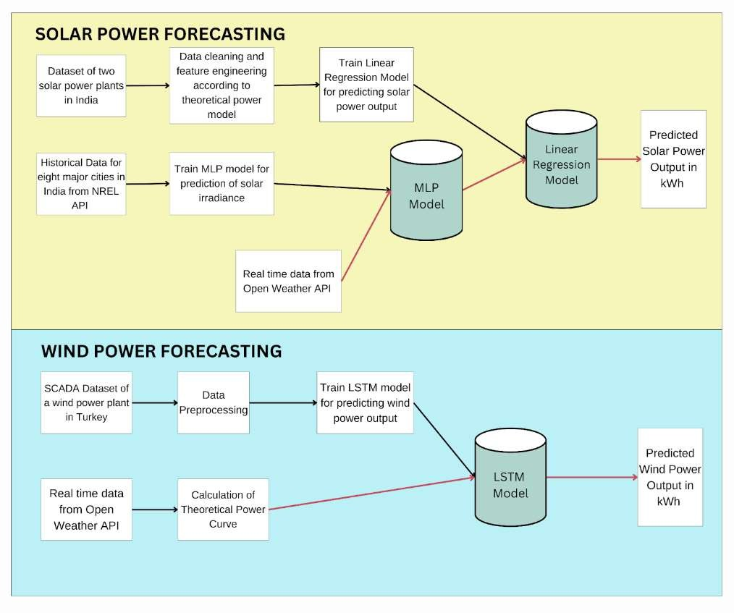

**Fig. 1.** Proposed system for solar and wind power forecasting

**Data Cleaning.** Addressing missing values in solar power datasets is crucial for ensuring the accuracy and reliability of subsequent analyses. A comprehensive analysis was conducted to identify and handle missing values, revealing distinct

8

patterns during both nighttime and daytime periods. Nighttime gaps, which corresponded to non-operational periods such as routine inspections, were reasonably imputed as zeros to accurately reflect the absence of power generation during these times. However, challenges arose during daylight hours, where intermittent production and unclear reasons suggested potential malfunctions or data recording errors. To manage missing values during daylight hours, a two-step approach was adopted. First, values were replaced with zeros during specified nighttime hours (18:30 to 6:00) to account for non-operational periods and ensure consistency in data representation. Subsequently, rows with AC power less than or equal to zero during daytime hours (6:30 to 18:00) were selectively removed to address data inconsistencies and maintain the integrity of the dataset.

Similarly, for the wind power dataset, missing values were dropped and the Date/Time feature was converted into a proper format to ensure consistency and ease of handling temporal data for subsequent analysis

**Theoretical Power Model for Solar Power Plants.** The theoretical model of a photovoltaic (PV) power plant incorporates equations describing the electrical behaviour of PV modules. The combined model provides a comprehensive understanding of how environmental factors such as solar irradiance and ambient temperature influence the AC power output of a PV system.

The following variables were considered:

𝑇𝑚 : Module temperature 𝑇𝑎 : Ambient temperature

𝐺𝑖𝑟 : Ground-level sun irradiance 𝑃𝑎𝑐 : Power Output The following are the constants required:

𝑇𝑜 : Standard Temperature (25°C 𝐺𝑜 : Standard Irradiation (1000 W/m²)

𝛼 : OCV Temperature Coefficient 𝛽 : DCV Temperature Coefficient

𝑉𝑜 : OCV at Standard Conditions 𝐼𝑜 : DCV at Standard Conditions

\**OCV: Open Circuit Voltage, DCV: Direct Circuit Voltage*

The photovoltaic power output 𝑃𝑎𝑐 is modelled as the product of the Thèvenin voltage 𝑉𝑡ℎ and the Mayer-Norton current

𝑃𝑎𝑐 = 𝑉𝑡ℎ . 𝐼𝑛𝑜 (1)

Thèvenin voltage and Mayer-Norton current are defined as follows:

𝑉𝑡ℎ = 𝑉𝑜 [1 + (𝑇𝑚 − 𝑇𝑜)] (2)

9

𝐼𝑛𝑜 = 𝐼𝑜 [1 + (𝑇𝑚 − 𝑇𝑜)](Gir) (3)

Go

The module temperature is directly proportional to 𝐺𝑖𝑟 and 𝑇𝑎

𝑇𝑚 = 30 − 0.0175(𝐺𝑖𝑟 − 300) + 1.14(𝑇𝑎 − 25) (4)

On Replacing equations (2), (3), and (4) into equation (1)

𝑃𝑎𝑐 = 𝐾1𝐺𝑖𝑟3 + 𝐾2𝐺𝑖𝑟2 + 𝐾3𝐺𝑖𝑟2𝑇𝑎 + 𝐾4𝐺𝑖𝑟𝑇𝑎2 + 𝐾5𝐺𝑖𝑟𝑇𝑎 + 𝐾6𝐺𝑖𝑟 (5)

Equation (5) derived from the theoretical model [17] provides a foundation for selecting features crucial for predicting AC Power in a photovoltaic power plant.

**Feature Engineering.** To better align with the theoretical model of a photovoltaic (PV) power plant, the raw data attributes were modified through feature engineering. This process involved creating new features that represent the relationships between solar irradiance (Gir), ambient temperature (Ta), and AC power output more effectively. Solar irradiation values were standardized by adjusting its scale and new features like Gir3 and interactions such as Gir2Ta were introduced, to capture complex relationships within the dataset. These enhancements allow predictive models to better understand the dynamics of solar energy generation, resulting in more accurate forecasts essential for efficient energy planning and management.

**ML model for predicting solar power output.** Several machine learning models were employed to predict solar energy generation and to identify the most suitable regressor for accurately estimating AC power output from photovoltaic systems. These models included Linear Regression, Ridge Regression, Decision Tree Regression, Random Forest Regression, and K Nearest Neighbours Regression. Each model was evaluated based on its ability to capture the relationship between ambient temperature, solar irradiance, and solar energy generation. Through comprehensive analysis, we aimed to determine the most effective model for accurately forecasting solar energy production.

**Deep learning model for predicting irradiation.** In the absence of real-time irradiance data, a Multilayer Perceptron (MLP) model was implemented as a robust solution for predicting solar irradiance. This deep learning model architecture is well-suited for capturing complex patterns and relationships within the input data. The MLP consisted of multiple densely connected layers, allowing it to learn intricate dependencies between various environmental factors and irradiance levels. Each layer in the MLP utilized rectified linear unit activation functions, promoting non-linearity and enabling the model to capture nonlinear relationships inherent in solar irradiance prediction. Dropout layers were strategically incorporated to prevent overfitting by randomly deactivating neurons during training, thereby

10

enhancing the model's generalization capability. The model was trained using historical data obtained from the NREL API for eight cities in India, encompassing a wide range of environmental attributes such as temperature, pressure, relative humidity, wind speed, and wind direction. By optimizing the mean absolute error (MAE) loss function and employing the Adam optimizer with a learning rate of 0.001, the MLP underwent extensive training over 300 epochs with a batch size of 32.

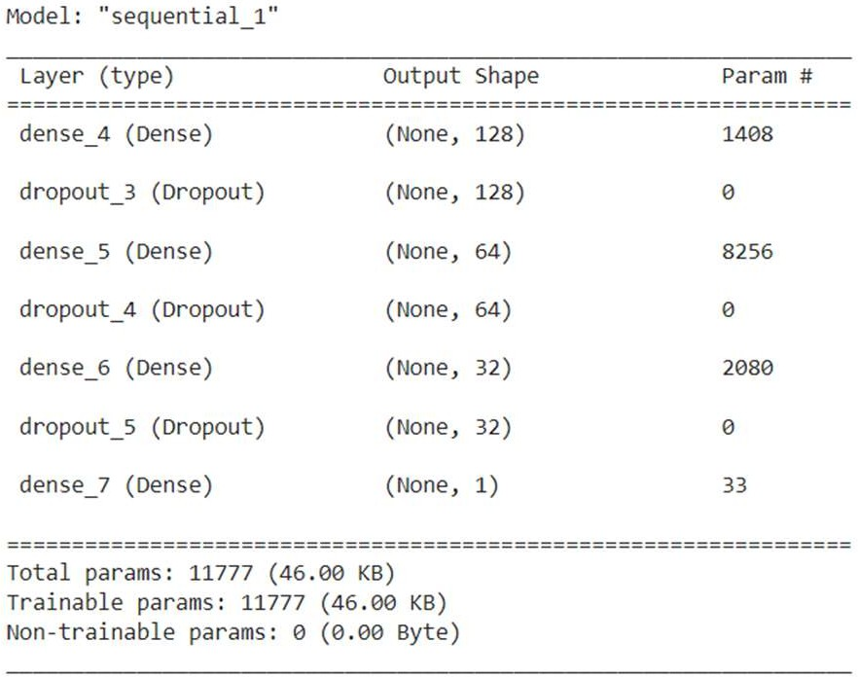

**Fig. 2.** MLP model summary for predicting solar irradiation

**Prediction of solar power output for real-time data.** For real-time prediction of solar power output, the proposed system employs a two-step approach using machine learning models. Firstly, real-time environmental data, including temperature, pressure, relative humidity, wind speed, and wind direction, is gathered from the OpenWeather API. This data is then fed into the trained Multilayer Perceptron (MLP) model for the prediction of solar irradiance. The MLP model, previously trained on historical data from the NREL API for accurate irradiance prediction, utilizes its learned patterns and relationships to estimate the current solar irradiance level.Subsequently, the predicted solar irradiance along with the real-time temperature data is combined, feature-engineered according to the theoretical power model, and is fed into a regression model specifically designed for predicting the AC power generated by the solar power plant.

**LSTM model for predicting power output for wind power plants.** In wind energy forecasting, accurate prediction of power output plays a pivotal role in optimizing energy generation and ensuring grid stability. To address this challenge, the proposed system employs a Long Short-Term Memory (LSTM) neural network model, a variant of recurrent neural networks (RNNs), known for its ability to capture long-term dependencies in sequential data. The LSTM model aims to predict wind turbine power output based on relevant features such as wind speed and theoretical power curve. From the dataset, pertinent features were selected such

11

as wind speed (m/s) and the theoretical power curve (KWh). These features, indicative of wind turbine performance, were normalized using min-max scaling to ensure uniformity across different attributes.

The LSTM model architecture comprised of a sequential stack of LSTM and Dense layers. The LSTM layer, with 100 units, served as the primary component responsible for learning temporal patterns and dependencies in the input sequences. Subsequently, a Dense output layer was employed to generate predictions based on the learned representations. The model was trained using the Adam optimiser, with mean square error as a loss function over 50 epochs with a batch size of 32.

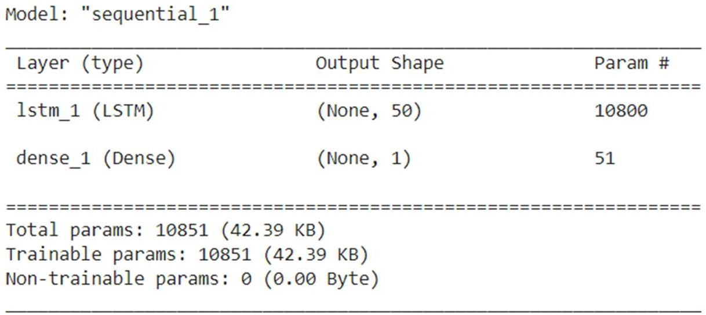

**Fig. 3.** LSTM model summary for predicting wind energy output

**Theoretical Power Output for Wind Power Plants.** In wind energy prediction, the theoretical power curve plays a pivotal role, serving as a fundamental factor in estimating the energy output of wind turbines. However, obtaining the theoretical power curve directly poses challenges as it is typically dependent on the wind speed at the turbine's hub height and varies based on turbine specifications determined by the manufacturer. Since this data is not readily available, the proposed system employs a calculation method to estimate the theoretical power output. This approach involves utilizing the formula

P = 0.5 * Cp * ρ * π * R^2 * V^3 (6)

where Cp represents the coefficient of performance or efficiency factor (expressed in percent), ρ denotes air density (measured in kg/m^3), R signifies the length of the rotor blades (measured in meters), and V represents the wind speed (measured in meters per second). Real-time wind speed (V) is extracted from the OpenWeather API, representing a crucial parameter influencing wind turbine performance. The efficiency of a wind turbine, often denoted as Cp, is assumed to be 0.45, a value within the typical range of 0.35 to 0.45 observed for small-scale residential turbines. Additionally, the length of the rotor blades (R), set at 5 meters, represents a standard value for small-scale residential turbines commonly deployed in domestic settings. Air density is determined using temperature and humidity data obtained from the

12

API. The formula incorporates dry and vapour air pressure to estimate air density accurately. Finally, the theoretical power output of the wind turbine is calculated by using the formula. This data is then fed to the model for prediction of wind power generation.

**Website Flow:** The website showcases real-time data for eight prominent cities in India, including Mumbai, Pune, New Delhi, Kanpur, Nagpur, Hyderabad, Bengaluru, and Jaipur, offering insights into both solar and wind power generation potential at each location. By providing detailed visualizations and comparisons, the platform equips energy planners with essential information to make informed decisions regarding renewable energy investments. Through real-time updates on solar irradiance levels, ambient temperatures, wind speeds, and theoretical power outputs, the website enables planners to assess the feasibility and economic viability of solar photovoltaic and wind turbine installations in specific regions. This data- driven approach empowers planners to identify optimal locations for renewable energy projects and formulate strategies for sustainable energy development in urban centres across India.

1. **Results and Discussion**
   1. **Solar Energy Prediction**

The study investigated the performance of various regression models in predicting solar energy output based on historical data from two photovoltaic power plants in India. Linear Regression, Ridge Regression, Decision Tree Regression, Random Forest Regression, and K Nearest Neighbours Regression were evaluated using factors like solar irradiance, ambient temperature, and AC power output. Linear Regression was the most accurate model and obtained a negative MSE of -3296.167 as seen in Table 2, showcasing its reliability despite its simplicity.

**Table 2.** Results of regression models

|  |  |
| --- | --- |
| Regressor | Negative MSE |
| Linear | -3296.167 |
| Ridge | -3329.264 |
| Decision Tree | -4067.456 |
| Random Forest | -6769.462 |
| KNN | -9986.437 |

13

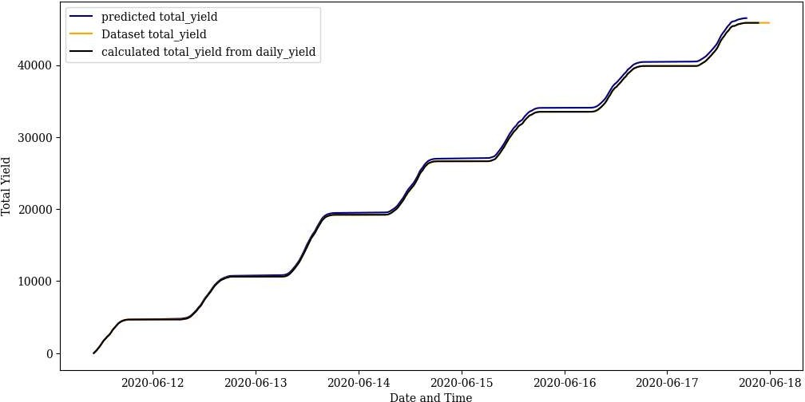

**Fig. 4.** Actual vs predicted values of solar power generated over time

Further, for the prediction of solar irradiation values for real-time data, a multilayer perceptron model was trained using weather data sourced from the National Renewable Energy Laboratory (NREL) API across eight Indian cities. Leveraging features such as temperature, pressure, relative humidity, and wind speed, the MLP model demonstrated adeptness in forecasting solar irradiance accurately and obtained a Mean Absolute Error (MAE) of 43.0289. Table 3 compares the actual and predicted irradiation values for Mumbai.

**Table 3.** Actual and predicted values for irradiation in Mumbai

|  |  |
| --- | --- |
| Actual Irradiance Value | Predicted Irradiance Value |
| 1.24 | 1.238230 |
| 1.22 | 1.228392 |
| 206.02 | 259.913300 |
| 1.23 | 1.237026 |
| 576.27 | 587.382141 |

* 1. **Wind Energy Prediction**

For wind power prediction, the system utilized a Long Short Term Memory (LSTM) model. The model was trained on historical wind speed data from wind turbines' SCADA system. This model demonstrated proficiency in capturing intricate temporal relationships, thereby enabling accurate forecasts of wind energy

14

generation. The model obtained a Mean Absolute Percent Error of 0.4615. Table 4 illustrates the comparison between actual and predicted wind power values for the test dataset.

**Table 4.** Actual and predicted values of wind power generation

|  |  |  |
| --- | --- | --- |
| Hour | Actual | Predicted |
| 1 | 3600.000 | 3606.497 |
| 5 | 1954.283 | 2513.598 |
| 10 | 3257.240 | 3151.348 |
| 15 | 1861.757 | 2292.190 |
| 20 | 3469.777 | 3594.405 |

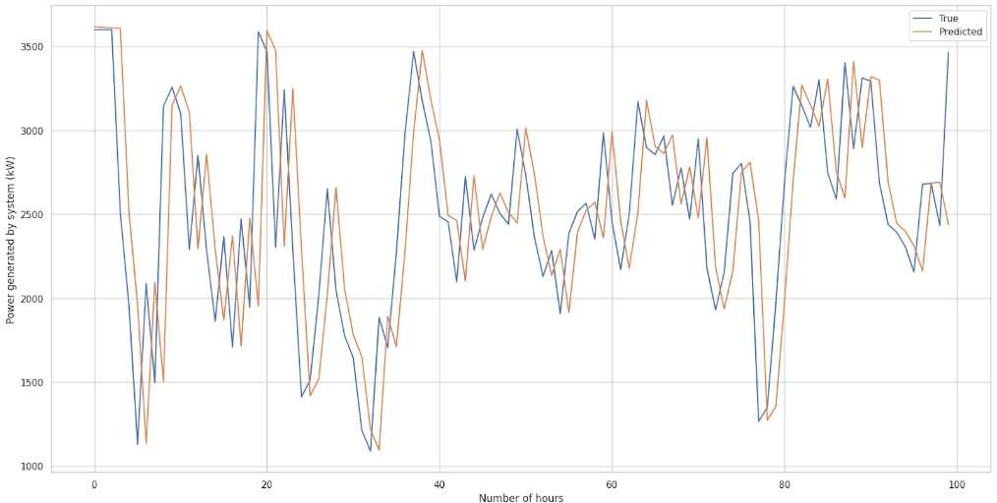

**Fig. 5.** Actual vs predicted values of wind power generated over time

* 1. **Comparison of Predicted Solar and Wind Energy Generation**

Table 5 presents data on solar and wind energy generation in Mumbai from March 14th, 2024, to March 18th, 2024. The weather data is gathered from the OpenWeather API and the theoretical power and irradiance values are calculated as specified in the methodology of the system. This data is fed to the machine learning models to predict the amount of solar and wind energy that can be generated at various times during the day providing insights into the potential of these renewable energy sources for residential regions. Solar energy generation is influenced by factors such as solar irradiance, ambient temperature, and relative humidity. From the data, it's observed that solar energy production fluctuates throughout the day,

15

peaking during midday when solar irradiance is highest. In Mumbai, wind energy generation demonstrates significant variability, influenced primarily by wind speed and direction. Notably, wind power generation tends to be higher compared to solar energy. This observation can be attributed to Mumbai's coastal location, which experiences frequent winds due to its proximity to the sea.

**Table 5.** Predicted solar and wind energy outputs for Mumbai

Date Time

Theoretical

Power Temperature

Wind

Speed GHI

Solar Energy

Wind Energy

|  |  |  |  |  |  |  |  |
| --- | --- | --- | --- | --- | --- | --- | --- |
| 14-03-24 | 10:00:00 | 0.63 | 37.36 | 3.13 | 852 | 1.08 | 4.54 |
| 14-03-24 | 13:00:00 | 2.52 | 33.36 | 4.97 | 884 | 1.13 | 22.64 |
| 14-03-24 | 18:00:00 | 0.78 | 29.91 | 3.36 | 592 | 0.81 | 7.07 |
| 14-03-24 | 21:00:00 | 0.30 | 29.09 | 2.45 | 33 | 0.03 | 0.66 |
| 15-03-24 | 10:00:00 | 0.53 | 36.8 | 2.95 | 817 | 1.04 | 3.02 |
| 15-03-24 | 13:00:00 | 1.96 | 33.64 | 4.57 | 851 | 1.09 | 20.6 |
| 15-03-24 | 18:00:00 | 0.52 | 30.82 | 2.93 | 581 | 0.79 | 2.86 |
| 15-03-24 | 21:00:00 | 0.14 | 30.18 | 1.89 | 26 | 0.02 | 0.11 |
| 16-03-24 | 10:00:00 | 0.47 | 37.73 | 2.83 | 829 | 1.05 | 2.23 |
| 16-03-24 | 13:00:00 | 1.89 | 34.73 | 4.52 | 875 | 1.11 | 20.25 |
| 16-03-24 | 18:00:00 | 51.49 | 31.82 | 2.93 | 603 | 0.81 | 2.84 |
| 16-03-24 | 21:00:00 | 0.08 | 30.73 | 1.57 | 20 | 0.01 | 0.06 |
| 17-03-24 | 10:00:00 | 0.45 | 38 | 2.8 | 828 | 1.05 | 2.07 |
| 17-03-24 | 13:00:00 | 2.20 | 34.36 | 4.75 | 873 | 1.11 | 21.63 |
| 17-03-24 | 18:00:00 | 0.57 | 31.45 | 3.03 | 594 | 0.8 | 3.6 |
| 17-03-24 | 21:00:00 | 0.18 | 30.82 | 2.05 | 35 | 0.03 | 0.13 |
| 18-03-24 | 10:00:00 | 0.54 | 38.36 | 2.98 | 852 | 1.07 | 3.24 |
| 18-03-24 | 13:00:00 | 2.52 | 34.27 | 4.97 | 894 | 1.13 | 22.63 |
| 18-03-24 | 18:00:00 | 0.72 | 31.64 | 3.28 | 621 | 0.84 | 6.08 |
| 18-03-24 | 21:00:00 | 0.17 | 30.82 | 2.02 | 34 | 0.03 | 0.13 |

16

**Conclusion**

Renewable energy plays a crucial role in meeting contemporary energy demands while addressing environmental concerns. The proposed system employs predictive modelling techniques to forecast both solar and wind energy generation. By integrating these models into an intuitive web platform, the system enables real- time monitoring of energy production potential across major Indian cities. Through comprehensive visualizations and comparative analyses, energy planners gain valuable insights to optimize renewable energy utilization for smart cities and residential areas. The website can predict the generation of real-time data, providing up-to-the-minute information on energy availability and facilitating proactive energy management strategies. The linear regression model for solar energy prediction obtained a negative MSE of -3296.167, and the LSTM model for wind energy prediction obtained a MAPE of 0.4615. This holistic approach fosters sustainable energy practices and contributes to building greener, more resilient urban communities in India.

**References**

1. A. Nayak and L. Heistrene, "Hybrid Machine Learning Model for Forecasting Solar Power Generation," 2020 International Conference on Smart Grids and Energy Systems (SGES), Perth, Australia, 2020, pp. 910-915, doi: 10.1109/SGES51519.2020.00167.
2. Bouchaib Zazoum,Solar photovoltaic power prediction using different machine learning methods, Energy Reports, Volume 8, Supplement 1, 2022, Pages 19-25,ISSN 2352-4847, https://doi.org/10.1016/j.egyr.2021.11.183.
3. M. Z. Hassan, M. E. K. Ali, A. B. M. S. Ali and J. Kumar, "Forecasting Day-Ahead Solar Radiation Using Machine Learning Approach," 2017 4th Asia-Pacific World Congress on Computer Science and Engineering (APWC on CSE), Mana Island, Fiji, 2017, pp. 252-258, doi: 10.1109/APWConCSE.2017.00050.
4. S. Mishra, L. Tripathy, P. Satapathy, P. K. Dash and N. Sahani, "An Efficient Machine Learning Approach for Accurate Short Term Solar Power Prediction," 2020 International Conference on Computational Intelligence for Smart Power System and Sustainable Energy (CISPSSE), Keonjhar, India, 2020, pp. 1-6, doi: 10.1109/CISPSSE49931.2020.9212231.
5. A. M. Alam, Nahid-Al-Masood, I. Asif Razee and M. Zunaed, "Solar PV Power Forecasting Using Traditional Methods and Machine Learning Techniques," 2021 IEEE Kansas Power and Energy Conference (KPEC), Manhattan, KS, USA, 2021, pp. 1-5, doi: 10.1109/KPEC51835.2021.9446199.
6. W. Buwei, C. Jianfeng, W. Bo and F. Shuanglei, "A Solar Power Prediction Using Support Vector Machines Based on Multi-source Data Fusion," 2018 International Conference on Power System Technology (POWERCON), Guangzhou, China, 2018, pp. 4573-4577, doi: 10.1109/POWERCON.2018.8601672
7. T. Hai et al., "Global Solar Radiation Estimation and Climatic Variability Analysis Using Extreme Learning Machine Based Predictive Model," in IEEE Access, vol. 8, pp. 12026- 12042, 2020, doi: 10.1109/ACCESS.2020.2965303..
8. Li, Z., Ye, L., Zhao, Y. *et al.* Short-term wind power prediction based on extreme learning machine with error correction. *Prot Control Mod Power Syst* **1**, 1 (2016).

17

https://doi.org/10.1186/s41601-016-0016-y

1. Y. Zhang, H. Sun and Y. Guo, "Wind Power Prediction Based on PSO-SVR and Grey Combination Model," in IEEE Access, vol. 7, pp. 136254-136267, 2019, doi: 10.1109/ACCESS.2019.2942012.
2. A. Kerem, A. Saygin and R. Rahmani, "Wind Power Forecasting Using a New and Robust Hybrid Metaheuristic Approach: A Case Study of Multiple Locations," 2019 19th International Symposium on Electromagnetic Fields in Mechatronics, Electrical and Electronic Engineering (ISEF), Nancy, France, 2019, pp. 1-2, doi: 10.1109/ISEF45929.2019.9097023.
3. A. Kumar and A. B. M. S. Ali, "Prospects of wind energy production in the western Fiji

— An empirical study using machine learning forecasting algorithms," 2017 Australasian Universities Power Engineering Conference (AUPEC), Melbourne, VIC, Australia, 2017, pp. 1-5, doi: 10.1109/AUPEC.2017.8282443.

1. M. A. Ehsan, A. Shahirinia, N. Zhang and T. Oladunni, "Wind Speed Prediction and Visualization Using Long Short-Term Memory Networks (LSTM)," 2020 10th International Conference on Information Science and Technology (ICIST), Bath, London, and Plymouth, UK, 2020, pp. 234-240, doi: 10.1109/ICIST49303.2020.9202300.
2. S. Adjiri, H. Nedjari-Daaou and S. M. Boudia, "Prediction Of Vertical Wind Speed By Artificial Neural Network For Wind Energy Application In Algeria," 2018 International Conference on Wind Energy and Applications in Algeria (ICWEAA), Algiers, Algeria, 2018, pp. 1-7, doi: 10.1109/ICWEAA.2018.8605098.
3. https://[www.kaggle.com/datasets/anikannal/solar-power-generation-data](http://www.kaggle.com/datasets/anikannal/solar-power-generation-data)
4. https://nsrdb.nrel.gov/
5. https://openweathermap.org/api
6. Huang, Chiou-Jye & Huang, Mao-Ting & Chen, Chung-Cheng. (2013). A Novel Power Output Model for Photovoltaic Systems. International Journal of Smart Grid and Clean Energy. 2. 139-147. 10.12720/sgce.2.2.139-147.
7. Alvarez, L. F. J., Gonzalez, S. R., Lopez, A. D., Delgado, D. A. H., Espinosa, R., & Gutierrez, S. (2020). *Renewable Energy Prediction through Machine Learning Algorithms. 2020 IEEE ANDESCON.* doi:10.1109/andescon50619.2020.92
8. I. Garg, A. Raj and A. Jajoria, "Solar Power Production Forecasting in India using Machine Learning Approach," 2021 5th International Conference on Intelligent Computing and Control Systems (ICICCS), Madurai, India, 2021, pp. 1265-1272, doi: 10.1109/ICICCS51141.2021.9432263.
9. https://mnre.gov.in/wind-overview/
10. https://[www.kaggle.com/datasets/berkerisen/wind-turbine-scada-dataset](http://www.kaggle.com/datasets/berkerisen/wind-turbine-scada-dataset)

**Plagiarism Report**



**Project Review Sheet 1**



**Project Review Sheet 2**

